SUBCOURSE EDITION
SS0130 B

US ARMY SIGNAL CENTER AND FORT GORDON

PRINCIPLES OF RADIO WAVE
PROPAGATION (SC:25C)

EDITION DATE: FEBRUARY 2005

PRINCIPLES OF RADIO WAVE PROPAGATION

Subcourse Number SS0130

EDITION B

United States Army Signal Center and Fort Gordon
Fort Gordon, Georgia 30905-5000

10 Credit Hours

Edition Date: February 2005

SUBCOURSE OVERVIEW

This subcourse is designed to teach the principles of radio wave propagation.

The prerequisite for this subcourse is that you are a graduate of the Signal Officer Basic Course or its equivalent.

This subcourse reflects the doctrine which was current at the time it was prepared. In your own work situation, always refer to the latest official publications.

Unless otherwise stated, the masculine gender of singular pronouns is used to refer to both men and women.

TERMINAL LEARNING OBJECTIVE

ACTION: Describe the principles of radio waves and how they are propagated as ground waves and sky waves.

CONDITION: Given this subcourse.

STANDARD: To demonstrate competence on this task, you must achieve a minimum of 70 percent on the subcourse examination.

i SS0130

TABLE OF CONTENTS

Section Page

Subcourse Overview i

Administrative Instructions iii

Grading and Certification Requirement iii

Lesson 1: Principals of Wave Propagation 1-1

Practice Exercise 1-16

Answer Key and Feedback 1-18

Lesson 2: Principles of Ground Wave Propagation. 2-1

Practice Exercise 2-8

Answer Key and Feedback 2-10

Lesson 3: Principles of Sky Wave Propagation 3-1

Practice Exercise 3-12

Answer Key and Feedback 3-14

Appendix: Acronyms and Abbreviations A-1

Student Inquiry Sheets

SS0130 ii

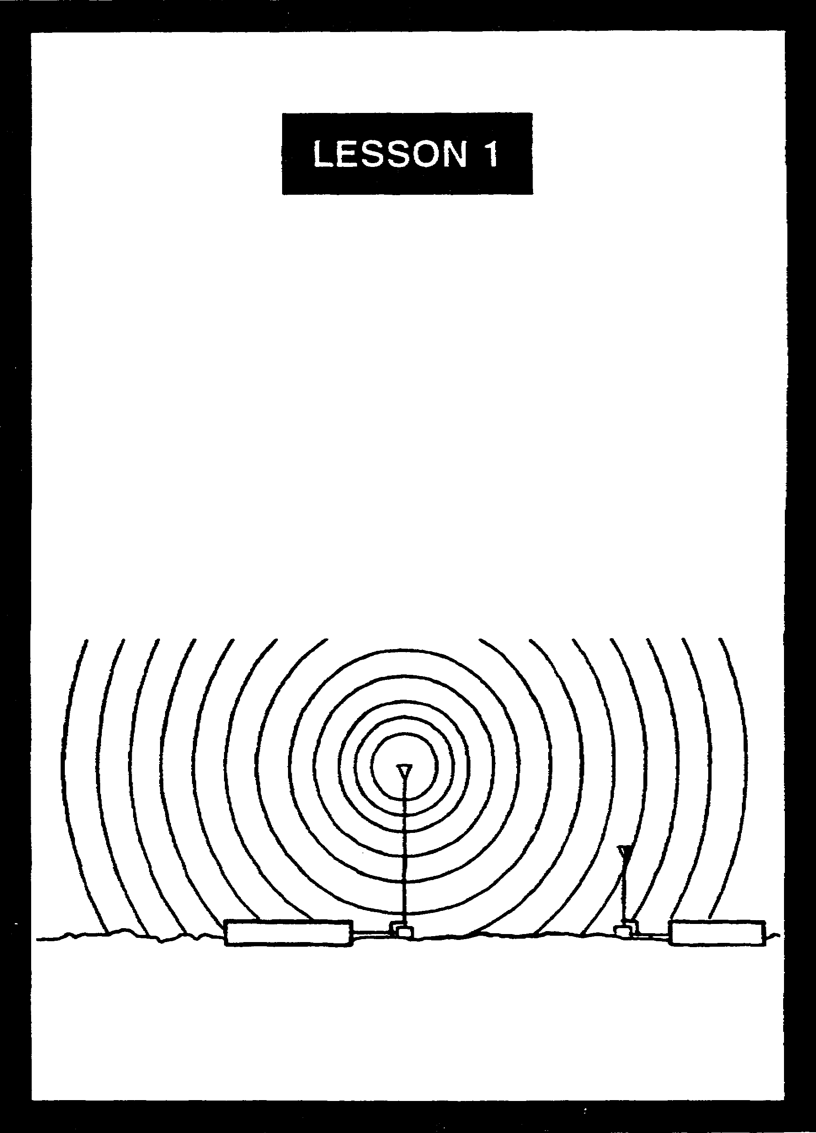

PRINCIPLES OF
WAVE PROPAGATION

LESSON 1

PRINCIPLES OF WAVE PROPAGATION

Critical Tasks: 01-5705.07-0003
01-5879.07-9001

OVERVIEW

LESSON DESCRIPTION:

In this lesson, you will learn about the fundamentals of radio wave propagation, modulation, and propagation characteristics through different media.

TERMINAL LEARNING OBJECTIVE:

ACTION: Identify the fundamentals of radio wave propagation.

CONDITION: Given this lesson.

STANDARD: To demonstrate competence, you must achieve a minimum of 70 percent on the subcourse examination.

REFERENCES: The material in this lesson was derived from FM 11-64, FM 24-18, and TM 11-666.

INTRODUCTION

For many, radio is a mysterious phenomenon that only technicians understand. All signal officers must be able to describe the nature of radio wave propagation and the forces that impede or enhance a radio signal. The more you know about how radio behaves, the better able you will be at providing reliable signal support, especially when faced with unexpected challenges.

1-1 SS0130

1. Radio wave propagation. A radio wave is a form of radiant energy (electromagnetic radiation) that propagates at the speed of light (186,000 miles or 300,000,000 meters per second). The following description of wave motion is based on FM 11-64, Transmission Lines, Wave Propagation, and Antennas.

a. A wave can be defined as a disturbance (sound, light, radio waves) which moves through a medium (air, water, vacuum). To help you understand what this means, think of the following picture. You are standing in the middle of a wheat field. As the wind blows across the field toward you, you see the wheat stalks bending and rising as the force of the wind moves into and across them. The wheat appears to be moving toward you, but it is not. Instead, the stalks are actually moving back and forth. We can then say that the medium is the wheat, and the disturbance is the wind moving the stalks of wheat.

b. Wave motion can be defined as a recurring disturbance advancing through space with or without the use of a physical medium. Therefore, it is a means of moving or transferring energy from one point to another point. For example, when sound waves strike a microphone, sound energy is converted into electrical energy. When light waves strike an antenna, they are likewise converted into electrical energy. Thus, sound, light, and radio waves are all forms of energy that are moved by wave motion.

c. The analogy of wave motion in water helps to explain the basic concept of how a radio wave propagates. Dropping a stone into a pool of water result in a disturbance of the water (the medium). From the point of impact, the disturbance is transmitted on the surface of the water as an expanding series of circular waves. Figure 1-1 depicts thin wave motion.

(1) View A shows the falling stone an instant before it strikes the water.

(2) View B illustrates the action that occurs when the stone strikes the surface, pushing the water upward and outward.

(3) In View C, the stone has sunk deeper into water, which has closed over it, while the leading wave has moved outward.

(4) View D shows the leading wave continuing to move outward, followed by a series of waves gradually diminishing in amplitude. Meanwhile, the disturbance at the original point of impact has gradually subsided.

(5) Note that the leading wave has amplitude and wavelength corresponding to one compete cycle. The water is not actually being moved by the outward motion of the wave, but rather by the up and down motion of the water. The up and down motion is traverse, or at right angles to the outward motion of the waves. This is called traverse wave motion.

SS0130 1-2

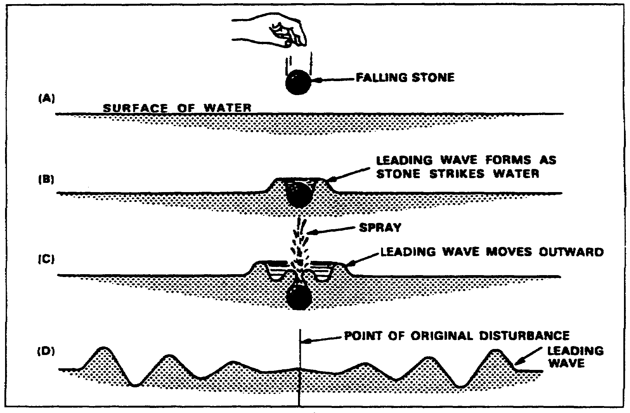
Figure 1-1. How a falling stone creates wave motion to the surface of water.

d. Figure 1-2 is a cross section of water waves, as viewed from the side. The waves are a succession of crests and troughs.

(1) A wavelength is the distance from the crest of one wave to the crest of the next, or between any two similar points on adjacent waves.

(2) The amplitude of a traverse wave is half the distance measured vertically from the crest to the trough.

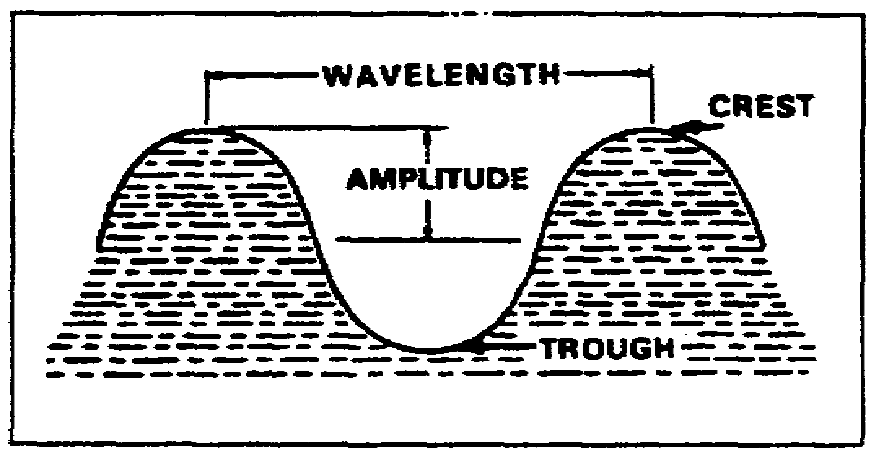
Figure 1-2. Elements of a wave.

1-3 SS0130

e. Figure 1-3 illustrates wave motion to help you better understand the terms associated with this action.

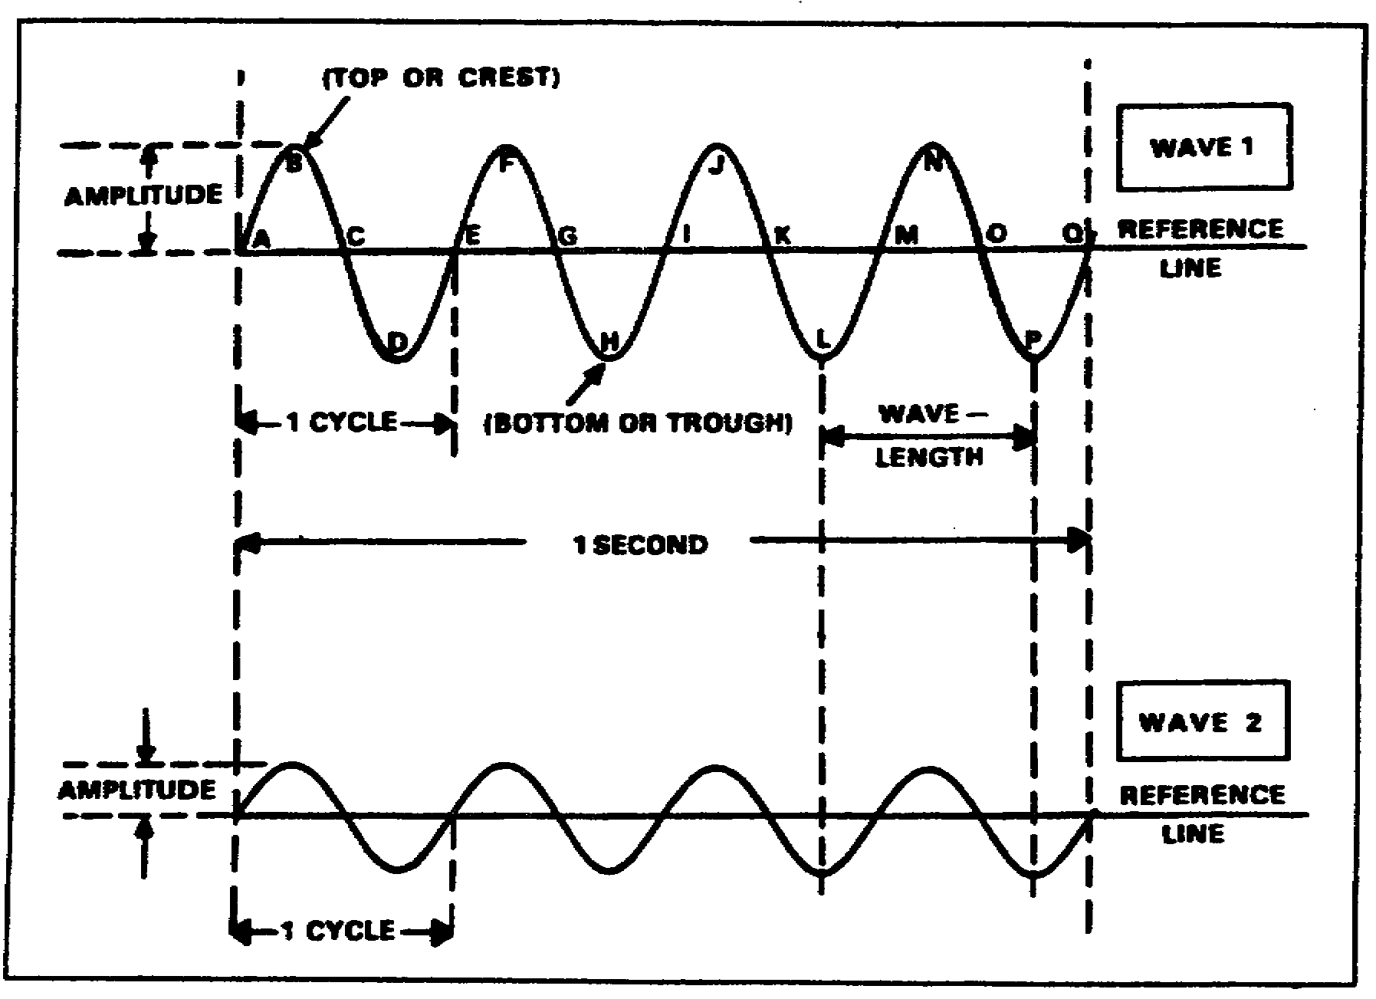
Figure 1-3. Comparison of waves with different amplitudes

(1) Waves 1 and 2 have equal frequency and wavelength, but different amplitudes. The reference line (rest position or point zero) is the position which a particle of matter would have if it were not disturbed by wave motion. In the case of the water wave, the reference line is the level of the water when no wave motion is present.

(2) Looking at wave 1, you will see it has four complete cycles. Points ABCDE illustrate one complete cycle; it has a maximum value above and a maximum value below the reference line. Any point above the reference line (between points A and C) is called a positive alternation, and any point below the reference line (between points C and E) is called a negative alternation. The combination of one complete positive and one complete negative alternation represent one cycle of waves. At point E, the wave begin to repeat itself.

f. A wavelength is the distance in space occupied by one cycle of a radio wave for a given period. Wavelengths vary from a few hundredths of an inch at extremely high frequencies, to many miles at extremely low frequencies. Wavelengths are, however, expressed in meters. For wave 1 in Figure 1-3, the distance between points A and E or points B and F is one wavelength.

SS0130 1-4

g. A wavelength is the distance in space occupied by one cycle of a radio wave for a given period. Wavelengths vary from a few hundredths of an inch at extremely high frequencies, to many miles at extremely low frequencies. Wavelengths are, however, expressed in meters. For wave 1 in Figure 1-3, the distance between paints A and E or points B and F is one wavelength.

h. Waves 1 and 2 both have the same wavelength, but different amplitudes. The height of a wave crest above the reference line is called the amplitude of the wave, which indicates the magnitude of energy the wave transmits. A continuous series of waves, having the same amplitude and wavelength, is called a wave train.

i. The number of cycles of a wave train in a unit of time is called the frequency of the wave train and is measured in hertz (Hz). The frequency of both waves 1 and 2 is four cycles per second. To honor the German physicist Heinrich Hertz, the term Hz was designated for use in lieu of the term "cycles per second" when referring to the frequency of radio waves. The frequency of household current is 60 Hz. The frequency of Army tactical radios is in the millions-of-Hz range.

2. Electromagnetic spectrum. The term spectrum is used to designate the entire range of electromagnetic waves arranged in the order of their frequencies. Figure 1-4, page 1-6, illustrates the electromagnetic spectrum. As illustrated, the spectrum represents a continuous array of electromagnetic waves arranged in the order of their frequencies. Note that the frequencies used for communications range from very low frequencies (VLF) at 3 kHz through super high frequencies (SHF) at 30 GHz. These frequencies are called radio frequencies (RF) Microwave signals are in the ultra high frequency (UHF) through the extremely high frequency (EHF) range.

a. Only a small portion of the spectrum contains visible waves (light) which the human eye can see. When you look at a rainbow, you see the various colors arranged in their order of frequency. The electromagnetic field and electromagnetic energy are the means of receiving and transferring energy from point to point. A radio antenna is used to radiate electromagnetic energy in the form of a radio wave. Figure 1-5, page 1-7, shows a simple radio communications system. Generated radio waves are radiated into space in all directions (omnidirectional) from the transmitting antenna, at the speed of light. Another antenna receives the energy, or signal. Thus, an antenna is a conductor that either radiates or collects electromagnetic energy.

b. The two fundamental fields associated with every antenna are an induction field and a radiation field.

(1) The induction field is associated with the energy stored in an antenna. As an antenna radiates electromagnetic energy, a magnetic field exists around it. Recall how your car radio responds when you drive past a high voltage transmission line. This interference is caused by the magnetic transmission line's field acting on your radio receiver. The induction field is considered a local field and plays no part in transmitting electromagnetic energy.

1-5 SS0130

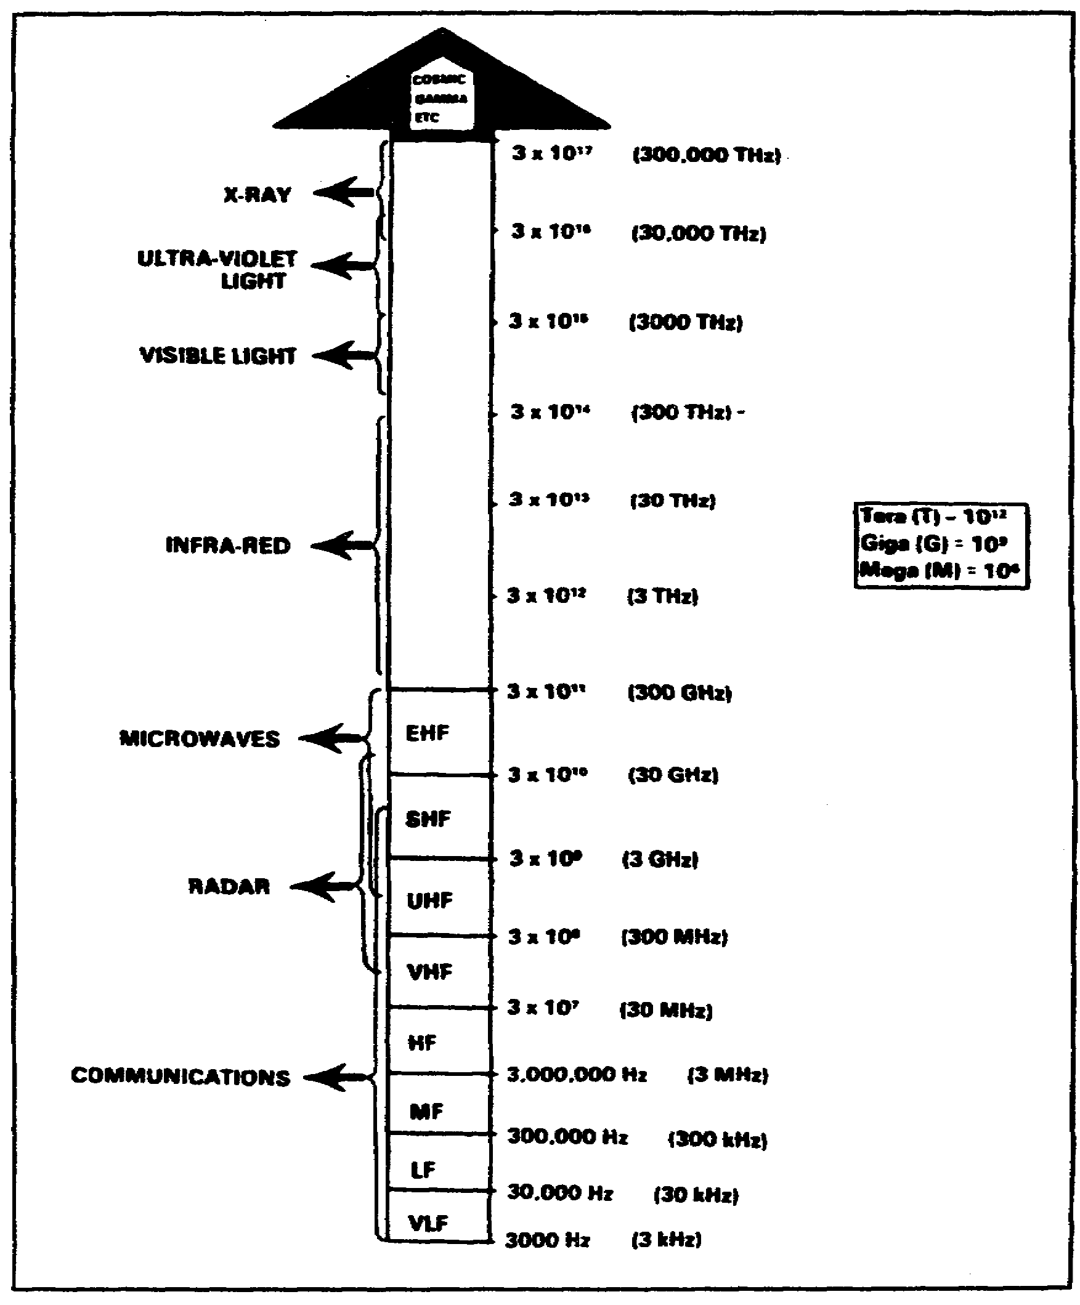
Figure 1-4. Electromagnetic spectrum.

SS0130 1-6

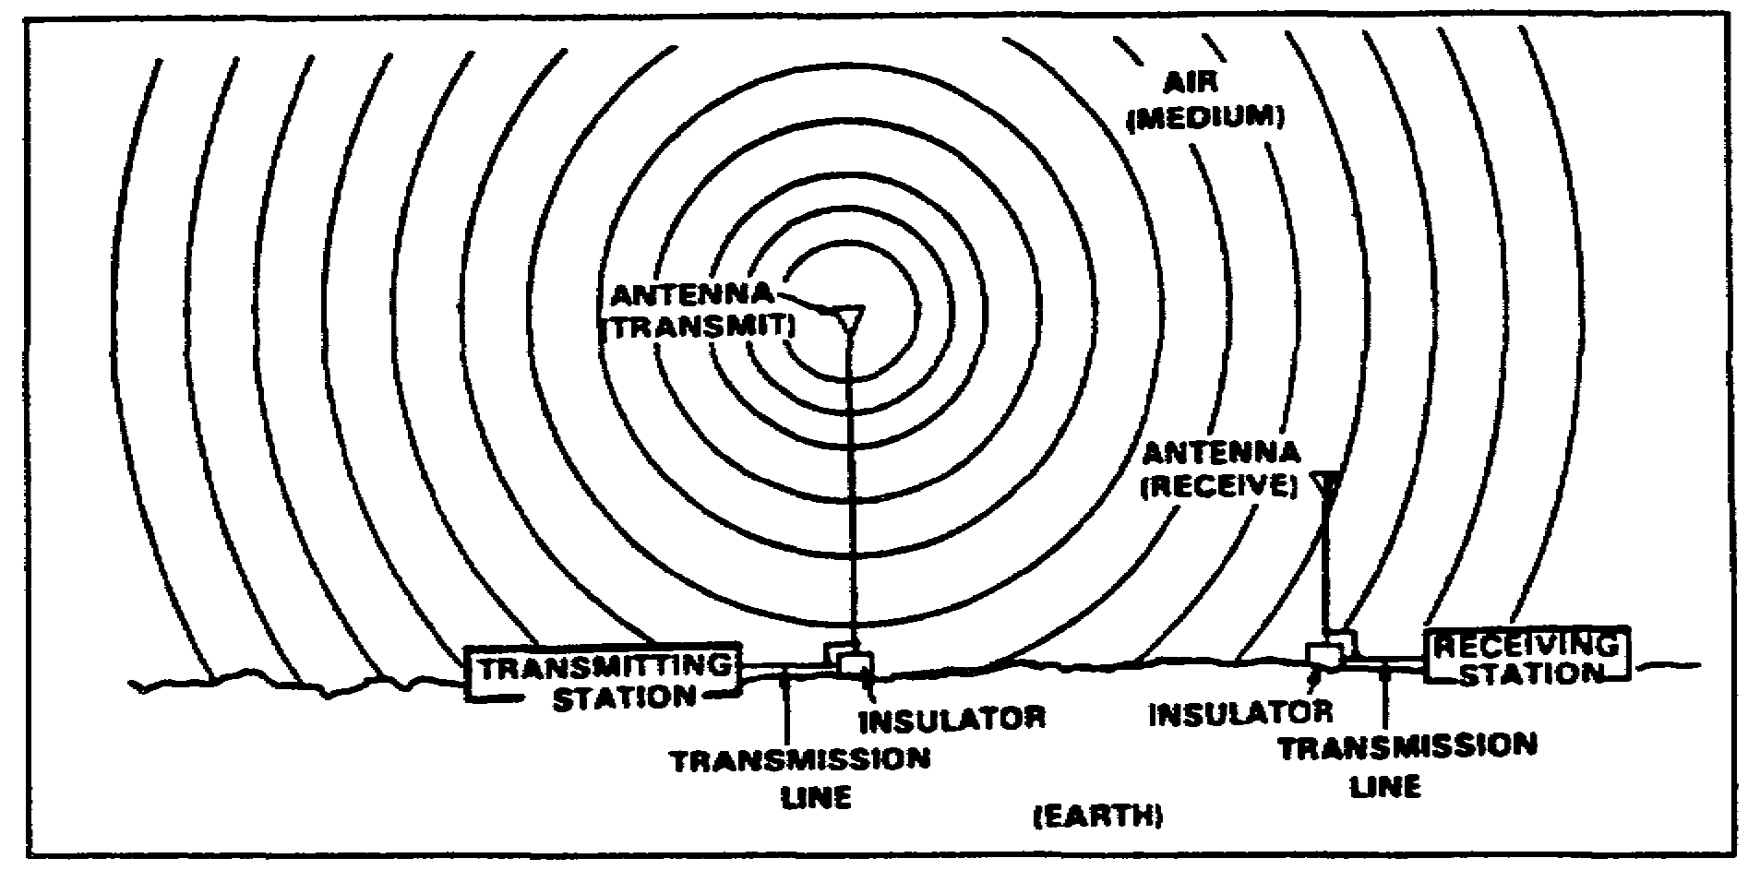
Figure 1-5. Simple radio communication system.

(2) The radiation field is responsible for electromagnetic radiation from the antenna. This field decreases as the distance from the antenna increases. Thus, when you are out of effective radio range, you can barely understand a transmission, or the signal is too weak to activate the receiver circuit. The term electromagnetic radiation was derived because a radio wave radiated into space by an antenna contains both electric and magnetic fields.

c. As mentioned earlier, frequencies falling between 3 kHz and 300 GHz are called RF, since they are commonly used in radio communications. The RF range of 3 kHz to 300 GHz is divided into bands of frequencies-a part of the RF spectrum. These frequency bands are detailed in Table 1-1, page 1-8. Each frequency band of the RF spectrum is ten times higher in frequency than the one immediately below it.

d. For a receiving antenna to pick up, or absorb the maximum amount of energy from an electromagnetic field, it must be located in the plane of polarization. This is simply a matter of orientation between the Earth and the electric field. If the lines of force in the electric field are perpendicular to the surface of the Earth, the wave is said to be vertically polarized. If the lines of fore are parallel with the Earth, the polarization is said to be horizontal Figure 1-6, page 1-9, shows both vertical and horizontal polarization. Notice that in view A, the electric lines are at right angles to the Earth's surface. In view B, the electric lines are parallel to the Earth's surface. Polarization affects the strength and range of a signal and is addressed during the planning process before executing signal operations. Polarization will be discussed in more detail in Lesson 2.

1-7 SS0130

Table 1-1. Radio frequency bands.
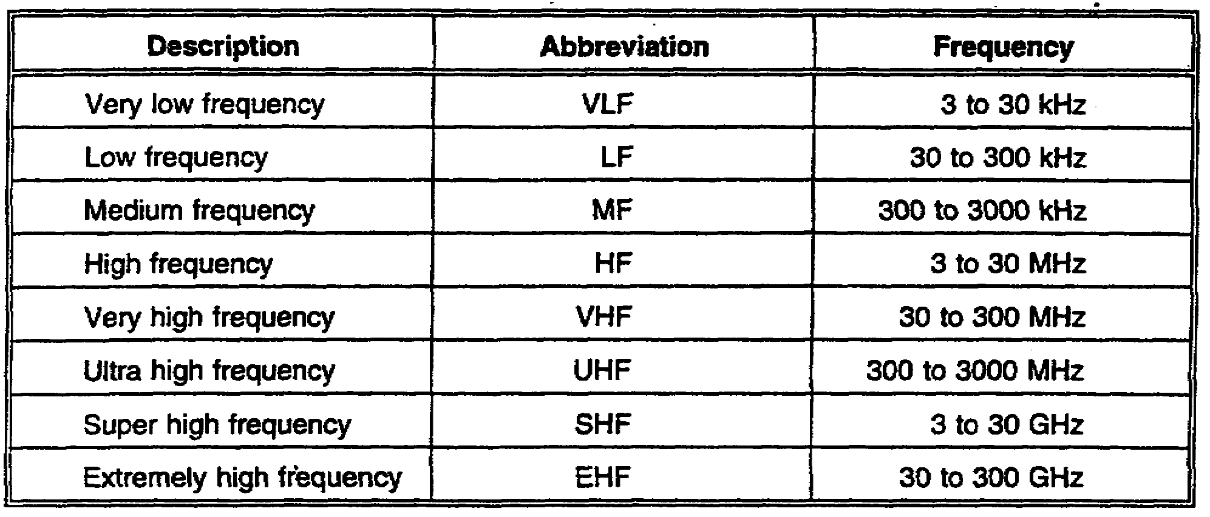

3. Modulation. Both amplitude modulation (AM) and frequency modulation (FM) transmitters produce RF carriers. The carrier is a wave of constant amplitude and frequency, which can be modulated by changing its amplitude or frequency (Figure 1-7, page 1-10). Thus, the RF carrier "carries" intelligence by being modulated. Modulation is the process of superimposing intelligence (voice or coded signals) on the carrier. The following discussion of modulation is based on FM 24-18, Tactical Single-Channel Radio Communications Techniques.

a. AM is defined as the variation of the RF power output of a transmitter at an audio rate. In other words, the RF energy increases and decreases in power according to the audio frequencies (AFs) superimposed on the carrier signal.

(1) When AF signals are superimposed on the RF carrier signal, additional RF signals are generated. These additional frequencies are equal to the sum and the difference of the AF signals and the RF used. For example, assume a 500 kHz carrier is modulated by a 1 kHz audio tone. Two new frequencies are developed. One is at 501 kHz (the sum of 500 kHz and 1 kHz) and the other is at 499 kHz (the difference between 500 kHz and 1 kHz). If a complex audio signal is used instead of a single tone, two new frequencies will be set up for each of the AF signals involved. The new frequencies that result from superimposing an AF signal on an RF signal are called sidebands.

SS0130 1-8

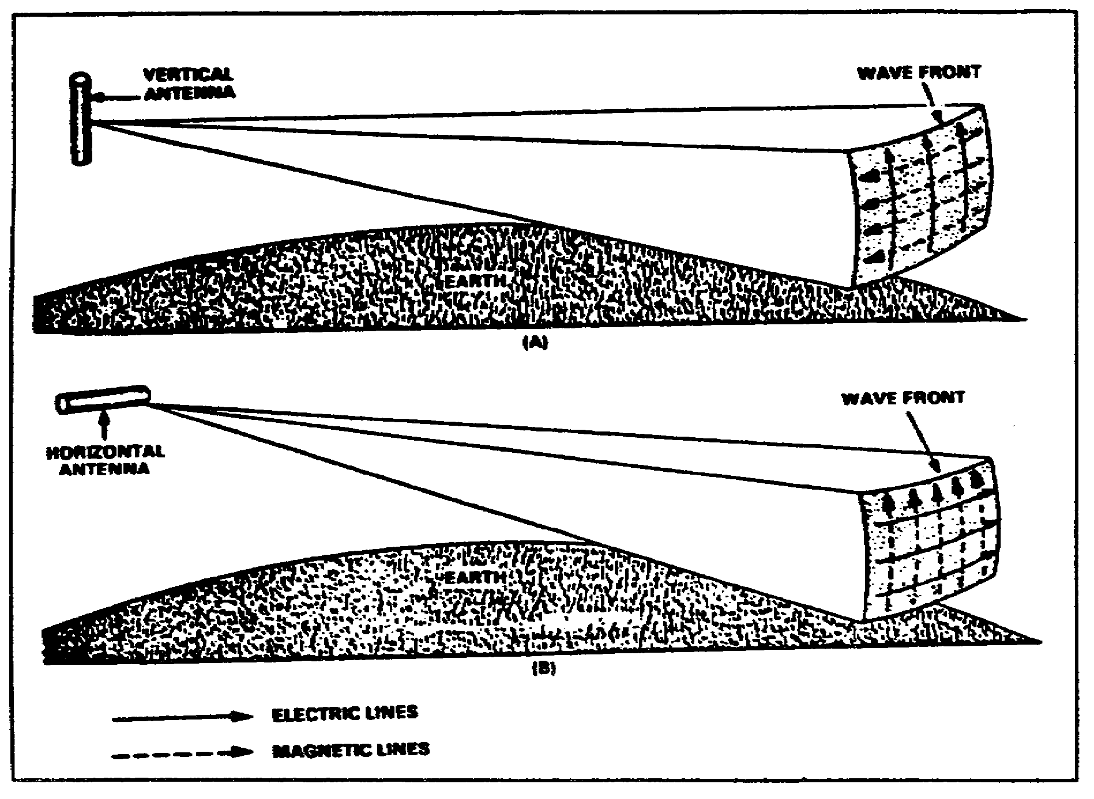
Figure 1-6. Vertical and horizontal polarization.

(2) As described above, when the RF carrier is modulated by complex tones such as speech, each separate frequency component of the modulating signal produces its own upper and lower sideband frequencies as shown in Figure 1-8, page 1-11. These additional frequencies occupy a band of frequencies which are called sidebands. The sideband that contains the sum of the RF and AF signals is called the upper sideband. The sideband that contains the difference between the RF and AF signals is called the lower sideband.

(3) The space occupied by a carrier and its associated sidebands in the radio frequency spectrum is called a channel. In AM, the width of the channel (bandwidth) is equal to twice the highest modulating frequency. For example, if a 5000 kHz (5 MHz) carrier is modulated by a band o frequencies ranging from 200 to 5000 cycles (.2 to 5 kHz), the upper sideband extends from 5000.2 to 5005 kHz. The lower sideband extends from 4999.8 kHz to 4995 kHz. Thus, the bandwidth is the difference between 4995 kHz and 5005 kHz, a total of 10 kHz.

1-9 SS0130

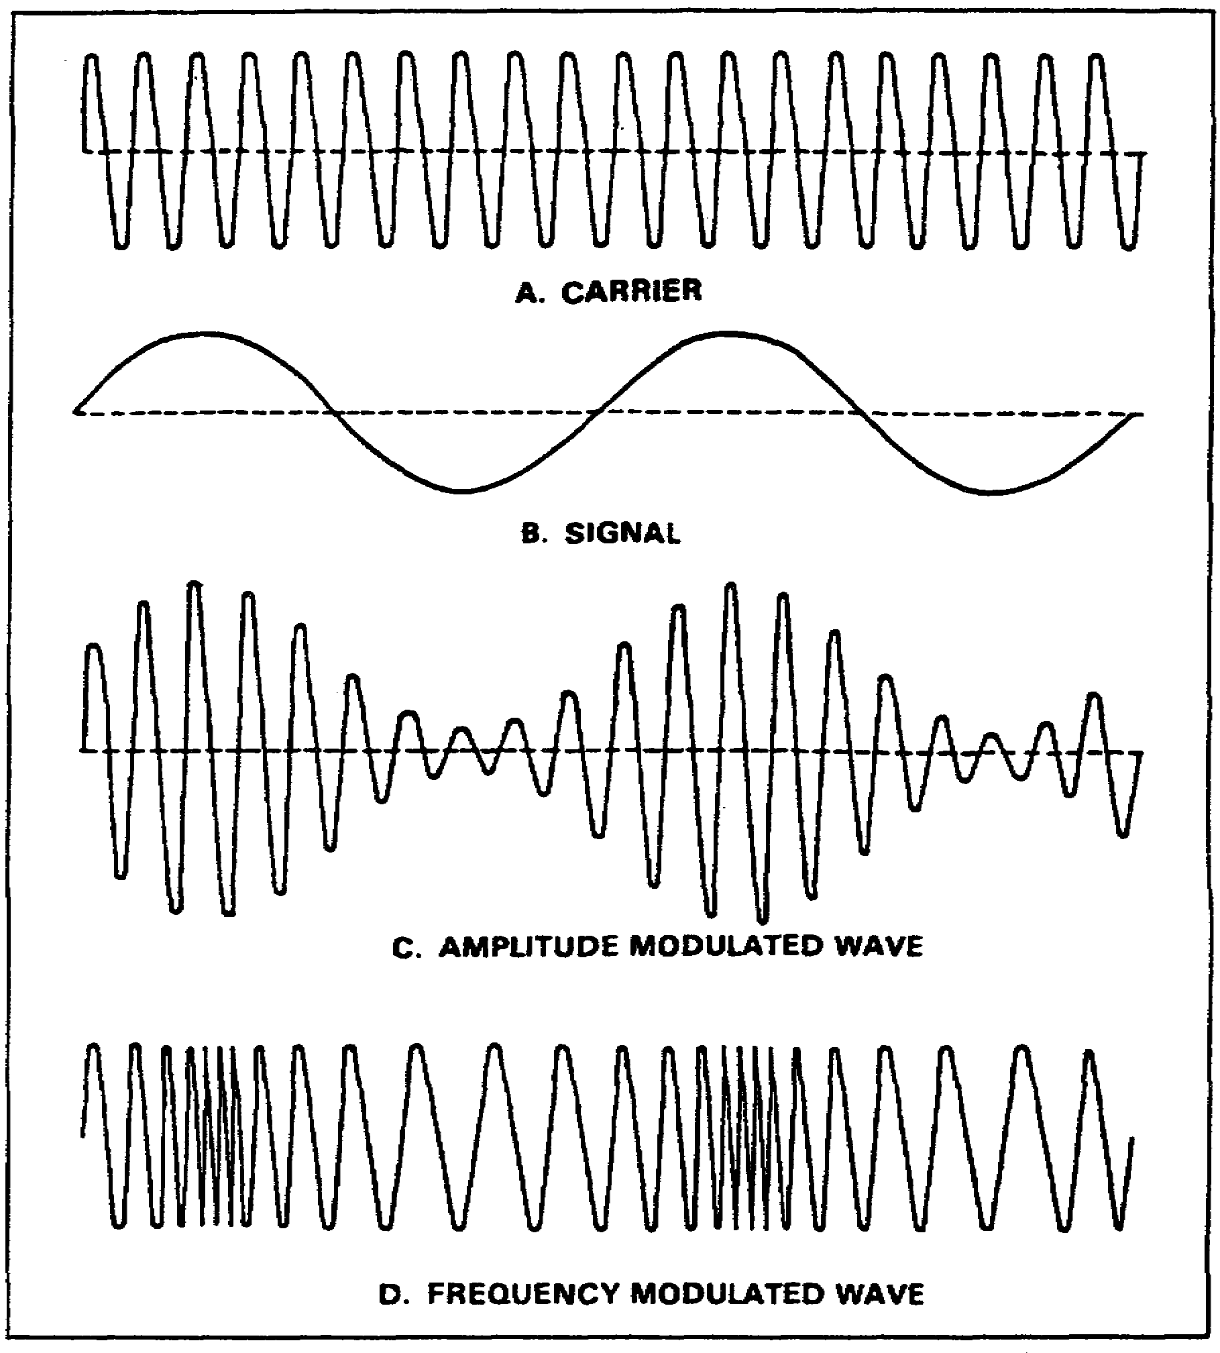
Figure 1-7. Wave shapes.

(4) AM is used by radiotelephone and teletypewriter transmitters operating in the medium and high frequency bands. The intelligence of an AM signal exists solely in the sidebands. It is susceptible to electrical storm interference. You may observe this by tuning in an AM station on your car radio during a thunderstorm. The interference happens the instant the lightning flashes.

SS0130 1-10

b. FM is the process of varying the carrier signal's frequency (rather than its amplitude) in accordance with the variations of the modulating signals. The amplitude or power of the FM carrier does not vary during modulation (Figure 1-9).

(1) The carrier signal's frequency, when it is not modulated, is called the center or rest frequency. When a modulating signal is applied to the carrier, the carrier signal will move up and down in frequency away from the center or rest frequency.

(2) The amplitude of the modulating signal determines how far away from the center frequency the carrier will move. This movement of the carrier is called deviation; how far the carrier moves is called the mount of deviation. During reception of the FM signal, the amount of deviation determines the loudness or volume of the signal.
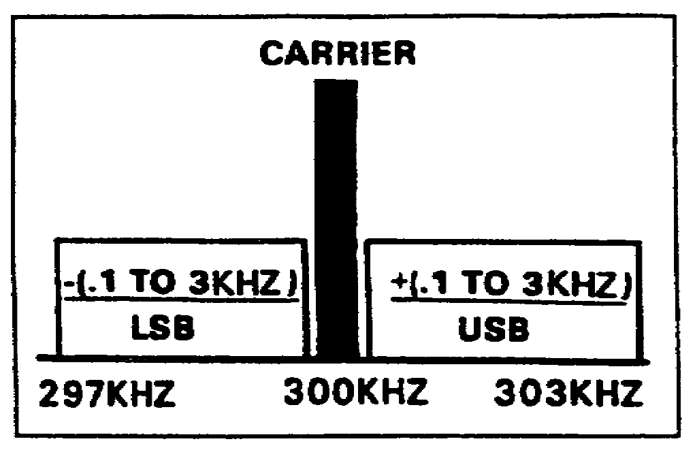
Figure 1-8. Amplitude-modulated system.

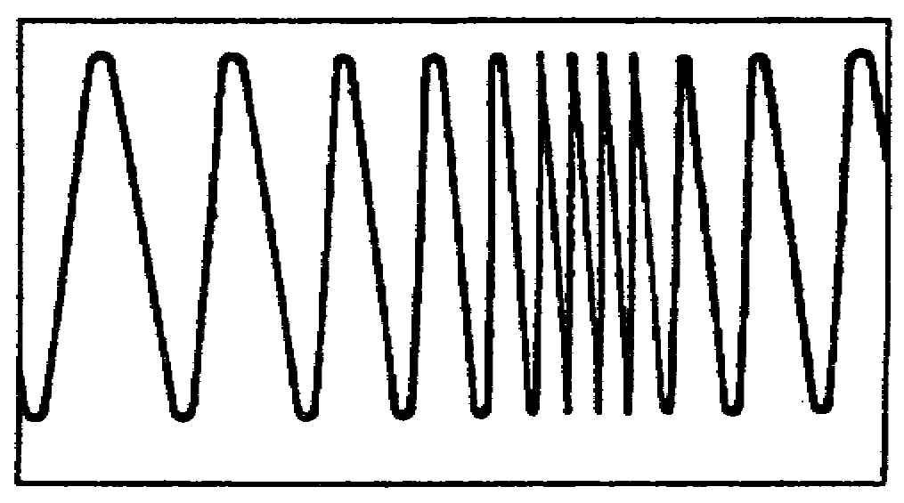
Figure 1-9. Frequency modulation.

(3) The FM signal leaving the transmitting antenna is constant in amplitude, but varying in frequency according to the audio signal. As the signal travels to the receiving antenna, it picks up natural and manmade electrical noises that cause amplitude variations in the signal. All of these undesirable amplitude variations are amplified as the signal passes through successive stages of the receiver until the signal reaches a part of the receiver called the limiter.

(4) The limiter eliminates the amplitude variations in the signal, then passes it on to a device called a discriminator, which is sensitive to variations in the RF wave's frequency. The resultant constant amplitude FM signal is then processed by the discriminator circuit, which changes the frequency variations into corresponding voltage amplitude variations. These voltage variations reproduce the original modulating signal in a headset, loudspeaker, or teletypewriter.

(5) FM is generally used by radiotelephone transmitter operating in the VHF and higher frequency bands.

1-11 SS0130

4. Behavior of radio waves in different media.

a. Radio waves are subject to the influence of the environment in which they are propagated. When a radio wave leaves the boundary of one medium and enters another, the wave changes direction. Three things can occur when a wave passes from one medium to another:

(1) Some of the energy can be reflected back into the initial medium.

(2) Some of the energy may be transmitted into the second medium where it may continue at a different velocity.

(3) Some of the energy may be absorbed by the medium.

b. Reflected waves are neither transmitted nor absorbed, but are reflected from the surface of the medium they encounter. The basic analogy that illustrates this concept is the mirror. Figure 1-10 illustrates the reflection of a light beam from a flashlight. If a wave is directed against a mirror, the wave that strikes the surface is called the incident wave, and the one that bounces back is called the reflected wave. This also occurs when a wave is transmitted skyward, reflect off the ionosphere, and returns to a receiving station. The angle of reflection equals the angle of incidence.

c. When a wave passes from one medium into a medium that has a different propagation velocity, a change in the direction of the wave will occur. This changing of direction is called refraction. Possibly the most common recollection of this is when you dip a spoon into a glass of water; the spoon handle appears bent. Figure 1-10 also shows how a wave is refracted (bent) as it travels from one medium to another, such as a radio wave bending as it passes through the atmosphere.

d. When a radio wave encounters an obstacle in its path, it bends around the obstacle. This bending is called diffraction, and results in a change of direction of part of the energy from the normal line-of-sight path. Figure 1-11 shows a signal that is diffracted around a mountain range. Between the mountains and the house, the closer you are to the house, the stronger the signal. Conversely, the closer you are to the mountains, the weaker the signal. When reconnoitering a hilly area prior to an operation, radio checks should be made to determine areas of poor radio reception.

e. Absorption occurs when radio waves are transmitted from one medium to another, with a resultant loss of energy. For example, if a radio signal is propagated through trees during the summer months, the foliage will absorb some of the energy of the signal. The same signal transmitted during the winter months may pass because the trees have shed their leaves and do not absorb the signal. A receiving antenna should be erected so that it is in the best position possible to absorb incoming electromagnetic energy.

SS0130 1-12

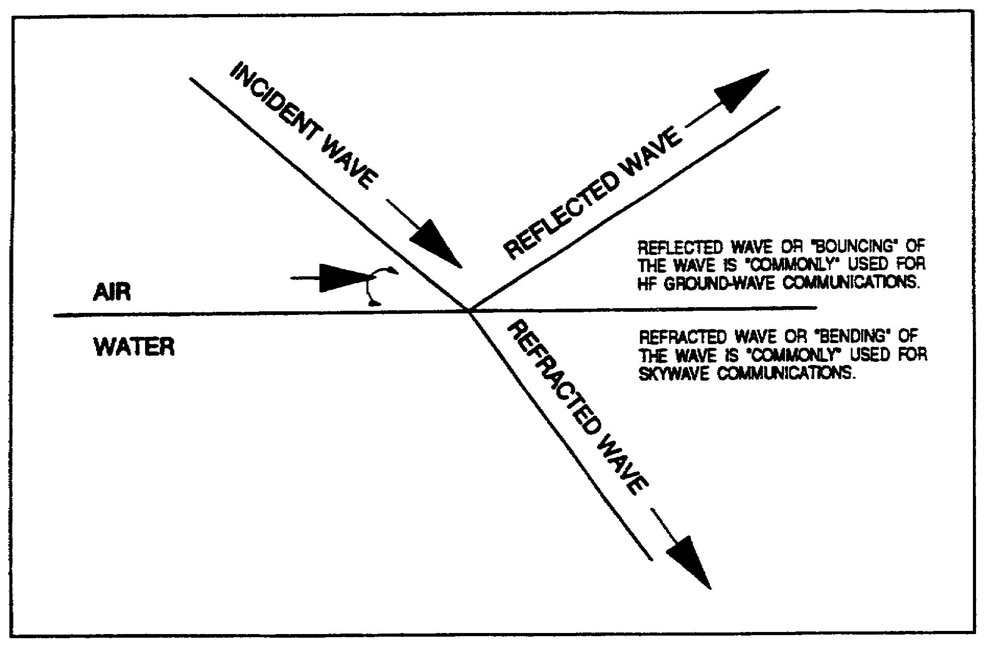
Figure 1-10. Reflection and refraction of a light beam.

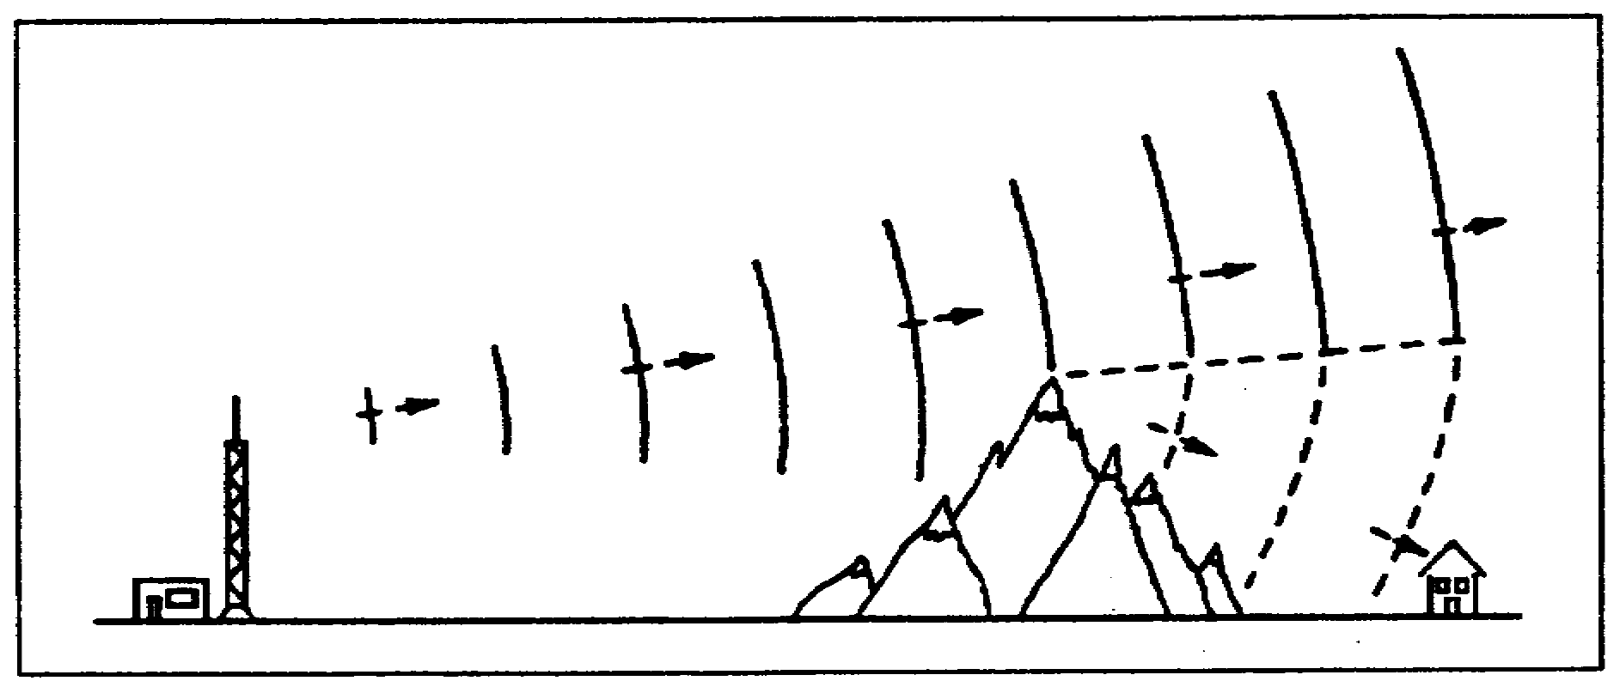
Figure 1-11. Diffraction of a TV signal over a mountain range.

1-13 SS0130

5. Summary. In this lesson, you learned about the fundamentals of radio wave propagation, modulation, and propagation characteristics through different media.

a. A cycle is one complete positive and negative alternation of current or voltage.

b. A wavelength is the distance an electromagnetic wave travels during the cycle.

c. Amplitude in the magnitude of energy of a wave, as measured from zero.

d. Frequency is the number of complete positive and negative cycles completed in a given period, normally per second.

e. The electromagnetic spectrum is the entire range of electromagnetic waves arranged in the order of their frequencies.

f. An induction field is the field associated with the energy stored in the antenna.

g. A radiation field is the field responsible for electromagnetic radiation from the antenna.

h. Polarization is the direction of a radiated signal, either horizontal or vertical.

i. AM is modulation in which the amplitude of a carrier wave is varied above and below its normal value in accordance with the intelligence of the signal being transmitted.

j. FM is the process of varying the frequency of a carrier wave, usually with an audio frequency, in order to convey intelligence.

k. Reflection is the turning back of a radio wave from an object on the surface of the Earth. Radio waves can also be reflected off the ionosphere.

l. Refraction is the bending or change in direction of a radio wave passing into another medium.

m. Diffraction is the bending of the path of waves when the waves are met with some form of obstruction.

n. Absorption is the removal of energy from a radiated field by objects which retain the energy or conduct it to ground. Loss by absorption reduces the strength of a radiated signal.

SS0130 1-14

GO TO THE NEXT PAGE

1-15 SS0130

LESSON 1

PRACTICE EXERCISE

The following items will test your grasp of the material covered in this lesson. There is only one correct answer for each item. When you complete the exercise, check your answers with the answer key that follows. If you answer any item incorrectly, study again that part of the lesson which contains the portion involved.

1. What is the electromagnetic field that is associated with the energy field stored in the antenna?

A. Induction field
B. Magnetic field
C. Radiation field
D. Modulation field

2. What is the range of electromagnetic waves arranged in order of their frequencies?

A. Amplitude
B. Wave propagation
C. Spectrum
D. Hertz

3. What is the height of a wave crest above the reference line?

A. Amplitude
B. Frequency
C. Cycle
D. Wavelength

4. The combination of one complete positive and one complete negative alternation is one ______.

A. Wavelength
B. Amplitude
C. Frequency
D. Cycle

5. The distance in space occupied by one cycle of a radio wave for a given period of time is ______.

A. Amplitude
B. Wave motion
C. Wavelength
D. Cycle

SS0130 1-16

6. What happens to a radio wave as it passes from one medium into another medium and changes direction?

A. It is refracted
B. It is attenuated
C. It is absorbed
D. It is diffracted

7. Varying the RF power output of a transmitter at an audio rate is what?

A. Frequency modulation
B. Phase modulation
C. Sideband modulation
D. Amplitude modulation

8. What is the process of superimposing voice or Morse code signals on a carrier wave?

A. Polarization
B. Modulation
C. Induction
D. Diffraction

1-17 SS0130

LESSON 1

PRACTICE EXERCISE

ANSWER KEY AND FEEDBACK

Item Correct Answer and Feedback

1. A. Induction field

The field that is associated with the energy stored in the antenna is the induction field. (page 1-5, para 2b(1))

2. C. Spectrum

The term spectrum is used to designate the entire range of electromagnetic waves arranged in the order of their frequencies. (page 1-5, para 2)

3. A. Amplitude

The height of a wave crest above the reference line is called the amplitude of the wave. (page 1-5, para 1h)

4. D. Cycle

The combination of one complete positive and one complete negative alternation represents one cycle of waves. (page 1-4, para le2))

5. C. Wavelength

A wavelength is the distance in space occupied by one cycle of a radio wave for a given period of time. (page 14, para 1f)

6. A. It is refracted

When a wave passes from one medium into a medium that has a different propagation velocity, a change in the direction of the wave will occur. This changing of direction is called refraction. (page 1-12, para 4c)

SS0130 1-18

Item Correct Answer and Feedback

7. D. Amplitude modulation

AM is defined as the variation of the RF power output of a transmitter at an audio rate. (page 1-8, para 3a)

8. B. Modulation

Modulation is the process of superimposing intelligence (voice or coded signals) on the carrier. (page 1-8, para 3)

1-19 SS0130

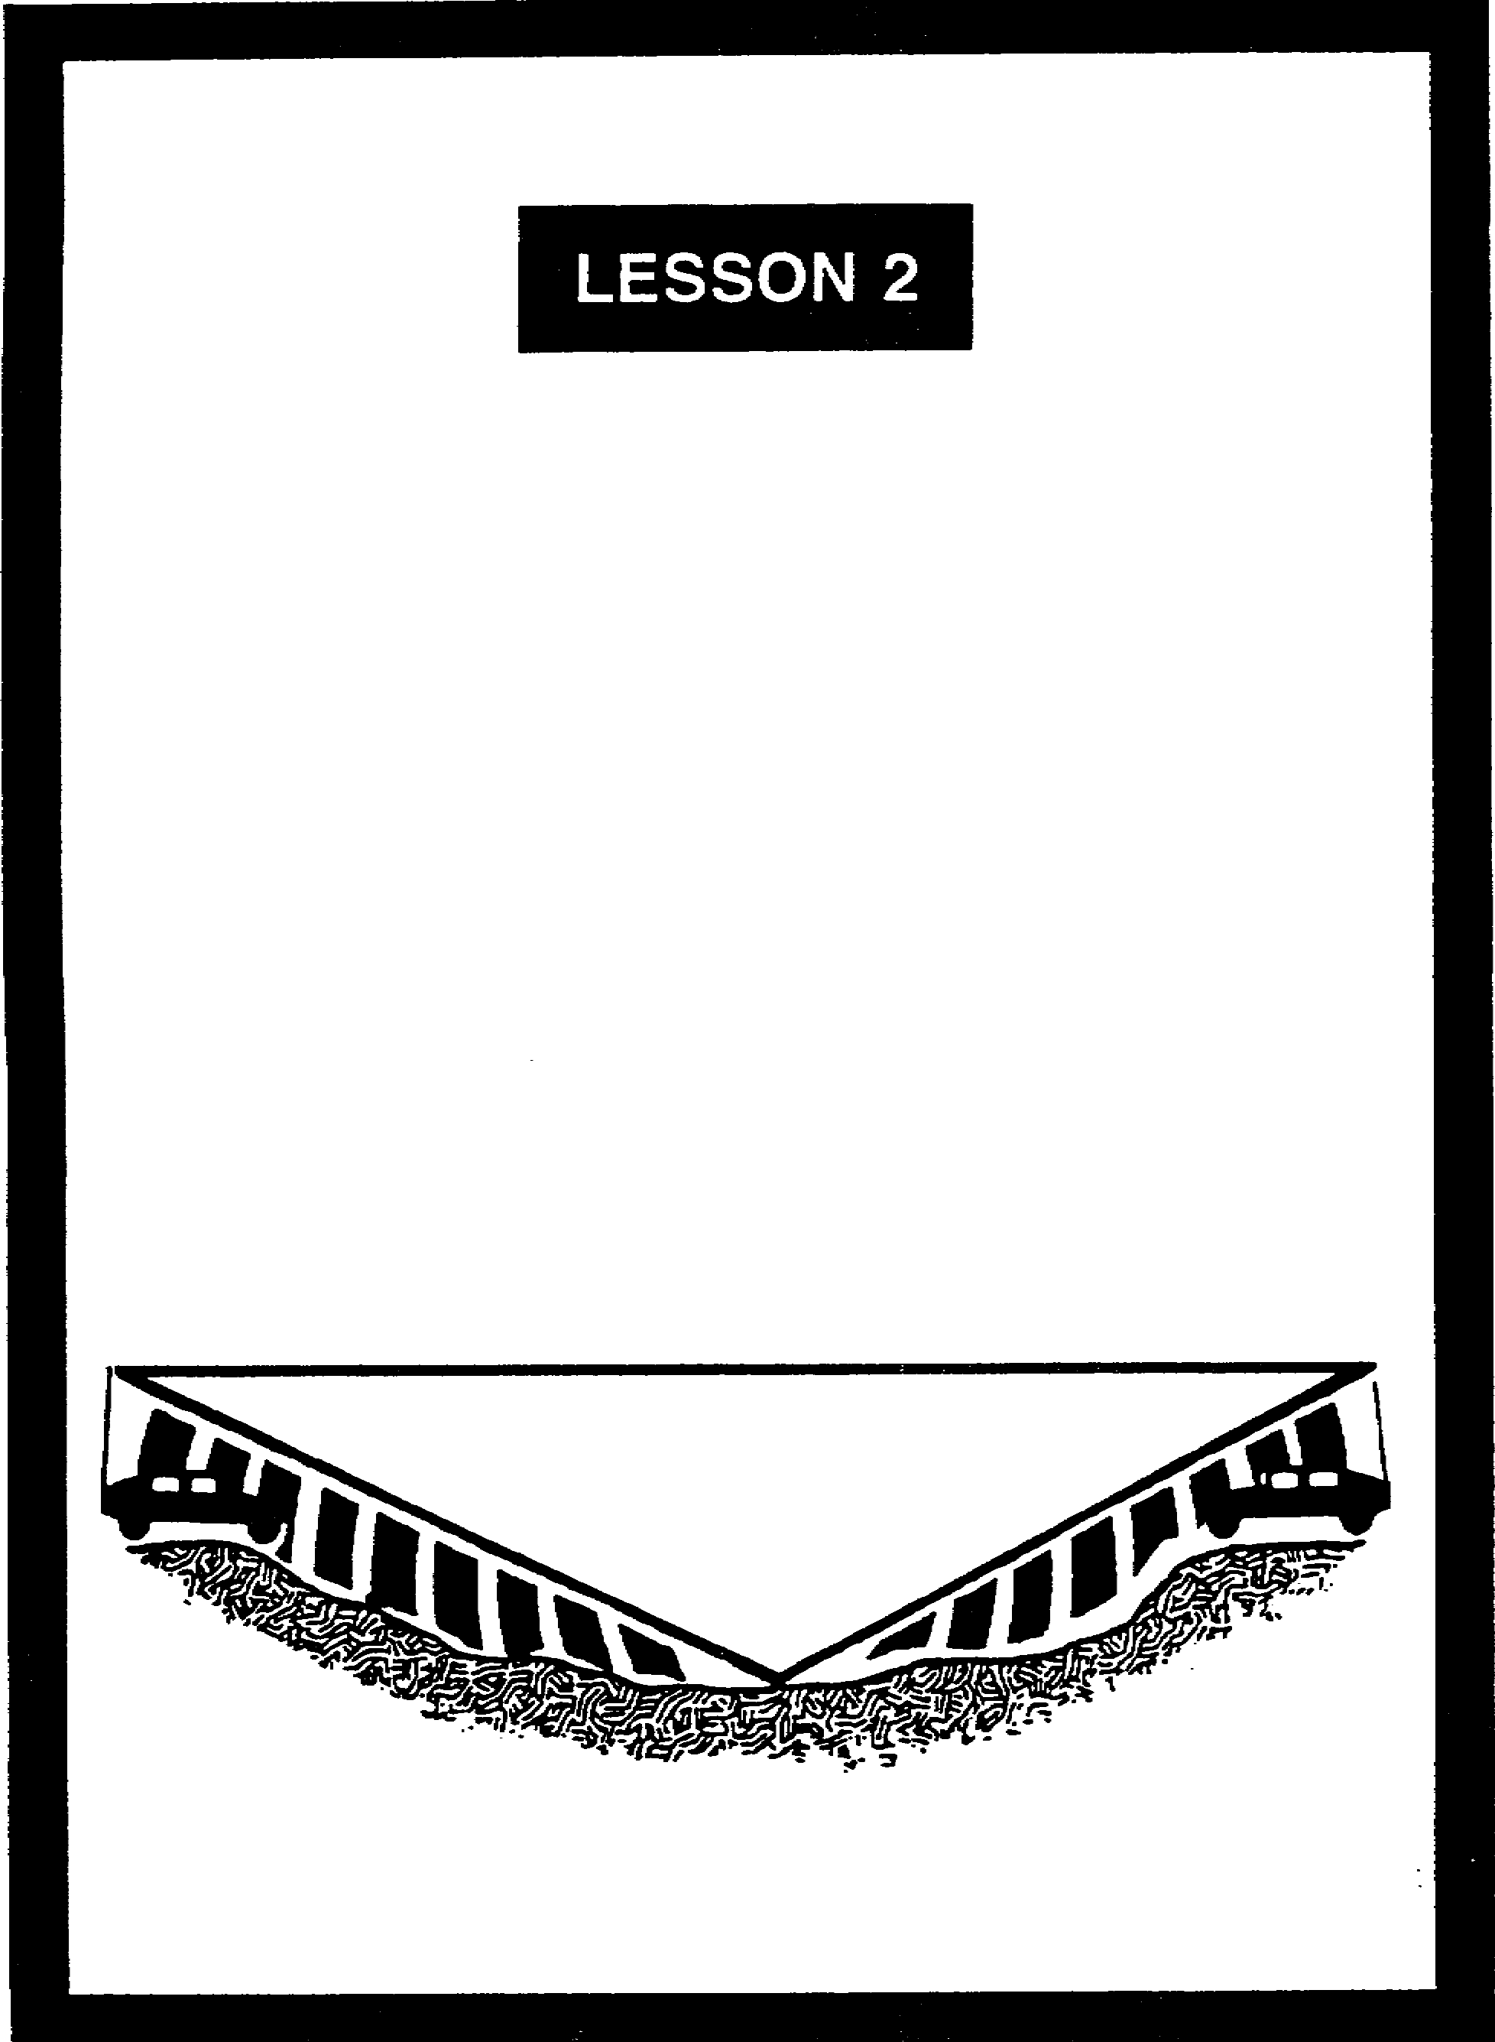

PRINCIPLES OF
GROUND WAVE PROPAGATION

LESSON 2

PRINCIPLES OF GROUND WAVE PROPAGATION

Critical Tasks: 01-5705.07-0003
01-5879.07-9001

OVERVIEW

LESSON DESCRIPTION:

In this lesson, you will learn about ground wave propagation and the terrestrial influences that affect communications.

TERMINAL LEARNING OBJECTIVE:

ACTION: Describe the basic principles of ground waves.

CONDITION: Given this lesson.

STANDARD: To demonstrate competence, you must achieve a minimum of 70 percent on the subcourse examination.

REFERENCES: The material in this lesson was derived from FM 11-64 and FM 24-18.

INTRODUCTION

Electromagnetic (radio) energy travels from a transmitting antenna to a receiving antenna in one of two ways--ground waves and sky waves. Signal officers who understand the dynamics of ground wave propagation often overcome communications problems and, thus, provide the best signal support possible.

2-1 SS0130

1. General. Ground waves travel near the surface of the Earth. Most Army tactical communications systems use ground wave propagation (single-channel voice, multichannel, and mobile subscriber equipment(MSE)). Sky waves are reflected back to Earth from the ionosphere. Other signal systems use sky wave propagation (tropospheric scatter radio, high frequency (HF) AM voice, and AM radio teletypewriter (RATT). Figure 2-1 depicts ground wave and sky wave propagation.

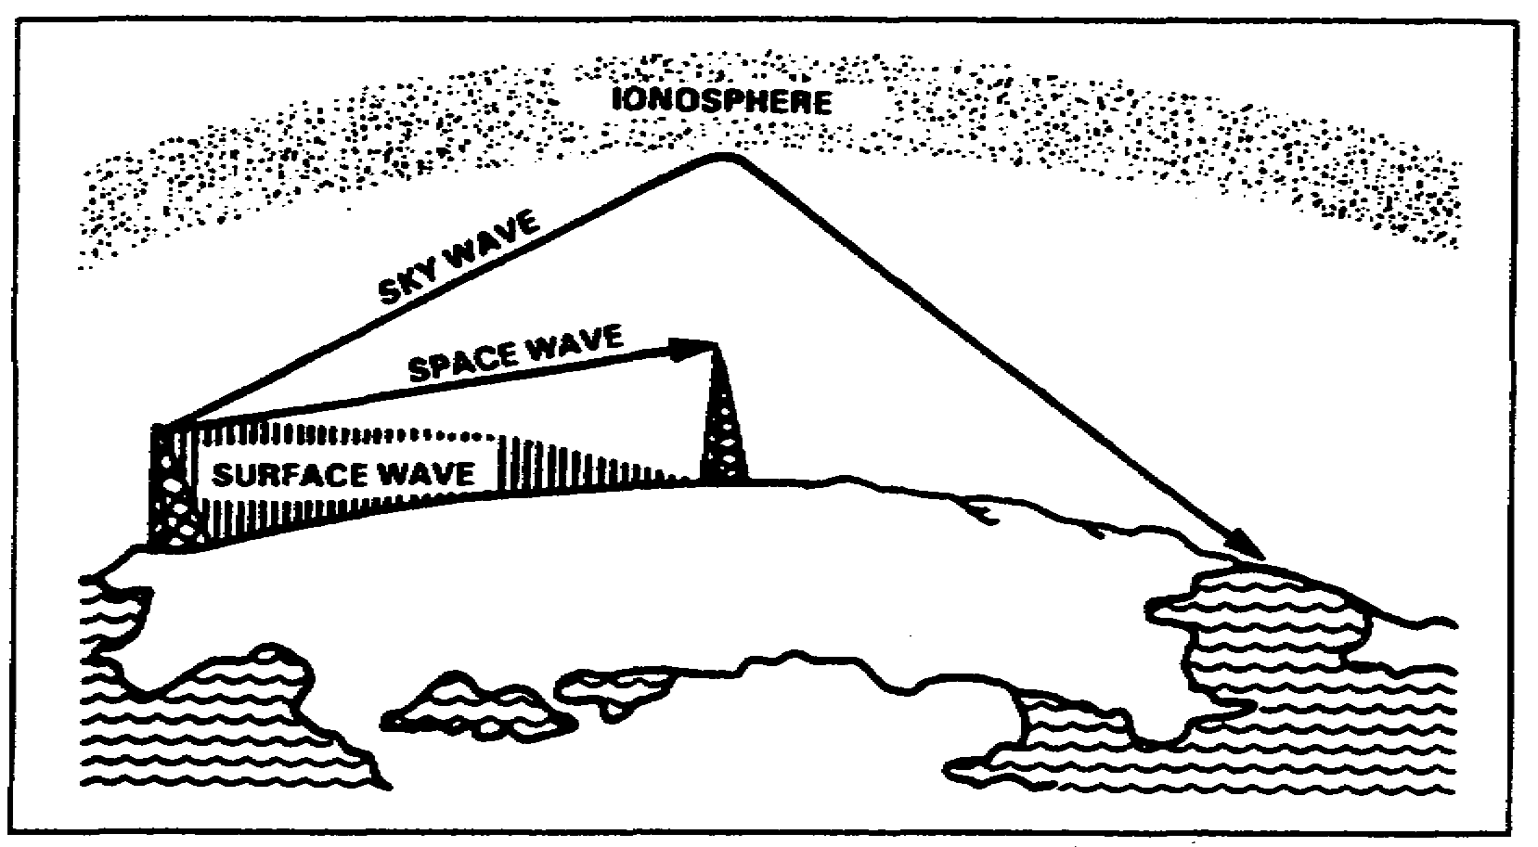
Figure 2-1. Ground waves and sky waves.

2. The Earth's atmosphere. Since the Earth's atmosphere is the medium through which radio signals are transmitted, it follows that these signals are affected by varying conditions (weather, electrical activity in the upper regions, and solar eruptions). The atmospheric conditions vary with changes in altitude, geographical location, and changes in time (day, night, season, year). The three separate regions (layers) of the Earth's atmosphere are the troposphere, the stratosphere, and the ionosphere. Figure 2-2 illustrates the layers of the atmosphere.

a. The troposphere extends from the face of the Earth to an altitude of about 7 miles at the north or south poles and 11 miles at the equator. The Earth's weather activity occurs in this region. It is very turbulent due to the temperature variations, density, and pressure, and these atmospheric conditions greatly affect radio wave propagation.

b. The stratosphere is located above the troposphere. It extends from a height of 7 miles at the poles (11 miles at the equator) to a height of about 31 miles. There is little water vapor present and the temperature is almost constant; consequently, this region has relatively little affect on radio waves.

SS0130 2-2

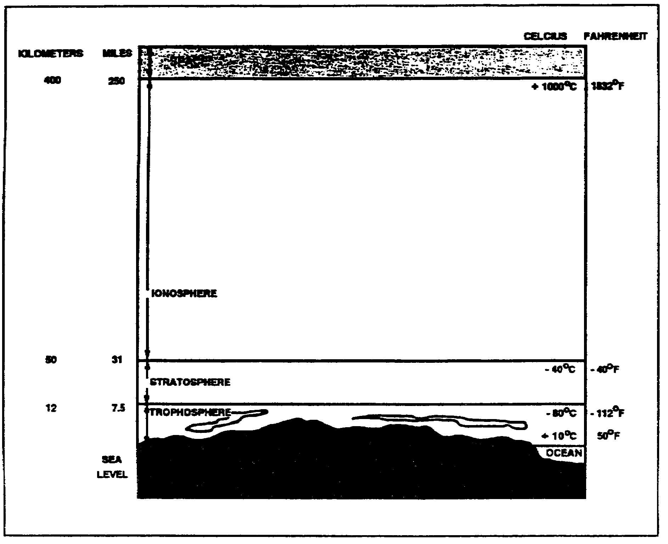
Figure 2-2. Layers of the Earth's atmosphere.

c. The ionosphere extends from about 31 miles to a height of about 250 miles. Four layers of electrically charged ions enable radio waves to be propagated to great distances around the Earth through reflection and refraction. This region of the atmosphere is the most important because of its use for long-distance, point-to-point communications. It will be discussed in detail in Lesson 3 of this subcourse.

3. Ground waves. Short-distance and all UHF and upper VHF transmissions are sent by ground waves. Ground wave propagation is affected by the Earth's electrical characteristics and by the amount of diffraction (bending) of the waves along the curvature of the Earth. The strength of the ground wave at the receiver depends on the transmitter's frequency and power output, the Earth's shape and conductivity along the transmission path, and the local weather conditions. A radio signal transmitted at high power on a low frequency will travel farther than a high frequency signal transmitted at low power. A good example of this is AM radio. The signal will also travel farther over a flat surface than over mountainous terrain. A ground wave is composed of two separate component waves-the surface wave and the space wave. Figure 2-3; page 2-4, depicts surface wave propagation.

2-3 SS0130

a. Surface wave.

(1) As shown in Figure 2-3, the surface wave travels along the surface of the ground. A surface wave flows the curvature of the Earth due to the process of diffraction. As a surface wave hits an object in its path, it tends to curve (bend) around the object.
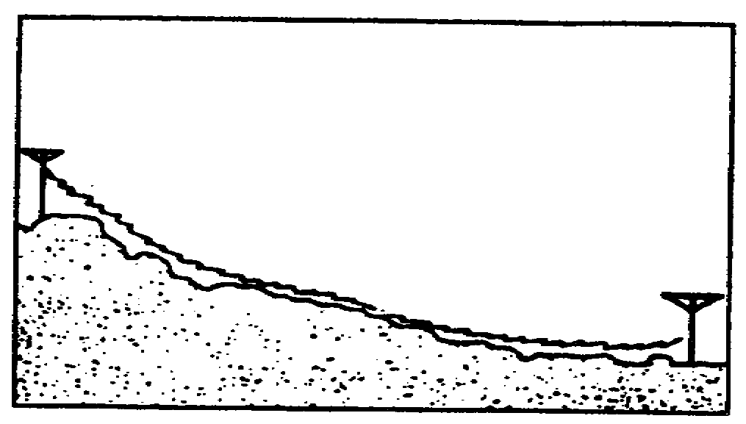
Figure 2-3. Surface wave propagation.

(2) As a surface wave passes over the ground, it induces voltage into Earth. The induced voltage takes energy away from the surface wave, thereby weakening (attenuating) the wave as it moves away from the transmitting antenna. To reduce attenuation, the amount of induced voltage must be reduced. This is done by using vertically polarized waves, which minimize the extent to which the electric field of the wave is in contact with the Earth. When the wave is horizontally polarized, the wave's electric field is parallel with the surface of the Earth and constantly in contact with it. As a transmission is made, the signal (horizontally polarized wave) is completely attenuated within a short distance from the transmitting site. Conversely, a vertically polarized surface wave has its electric field perpendicular to the Earth and merely dips onto and off of the Earth's surface. Because of the lower signal loss, vertical polarization is vastly superior to horizontal polarization for surface wave propagation.

(3) The amount of attenuation that a surface wave undergoes due to the induced voltage in the Earth also depends, to a considerable extent, on the electrical properties of the terrain over which the wave travels. The best type of surface is one which has good electrical conductivity. The better the conductivity, the less attenuation and the better the propagation. Table 2-1 shows the relative conductivity of various surfaces of the Earth.

(4) Each type of terrain shown has a different degree of conductivity-the ease at which radio waves propagate. Salt water has the best degree of conductivity. Because salt enhances conductivity, it can be used in the field when grounding a communications assemblage or generator. Moist land surfaces provide fair conductivity, while dry terrain provides poor conductivity and thus, impedes wave propagation. Jungle terrain is the worst environment, as the jungle vegetation absorbs the radio waves, reducing transmission range.

SS0130 2-4

Table 2-1. Surface conductivity.
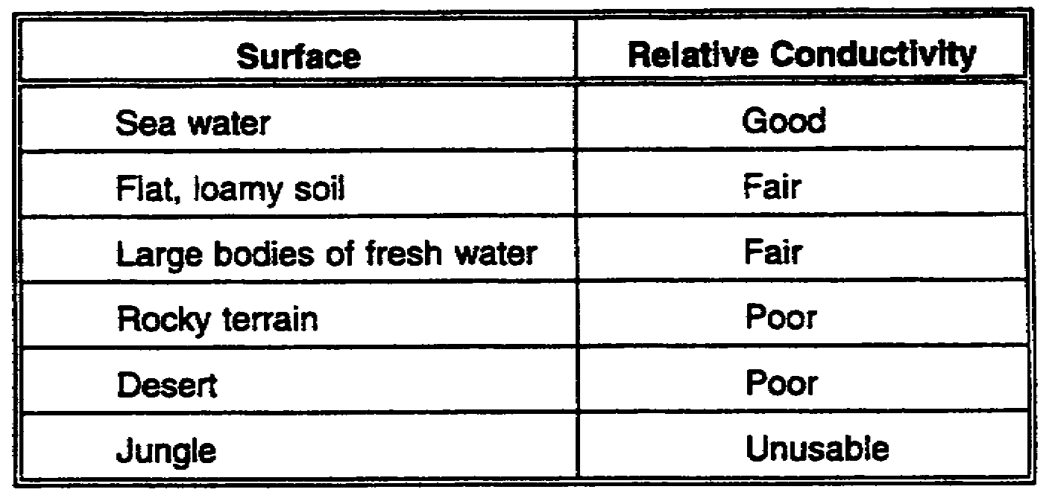

(5) A surface wave component, generally transmitted as a vertically polarized wave, remains vertically polarized at appreciable distances from the antenna. As mentioned before, vertically polarized waves do not lose power (attenuate) like horizontally polarized waves. The better the conducting surface, the less energy lost. Since no surface is a perfect conductor, any loss retards the grounded edge of a wave front, causing it to bend forward in the direction of travel so that successive wave fronts have a forward tilt. The Earth's surface guides the wave, and the tilt has the effect of propagating the energy in the direction of wave travel. Poor conducting surfaces cause a high loss of energy and greater tilt. The result is total absorption of wave energy. As frequency increases, the angle of tilt increases. A 20 MHz signal propagating over sea water has a very small tilt (one degree). Over dry ground, the same signal is tilted about 35 degrees.

(6) Frequency is a factor in surface wave attenuation.

(a) The higher a radio wave's frequency, the shorter its wavelength will be. These high frequencies, with their shorter wavelengths, are not normally diffracted, but are absorbed by the Earth at points relatively close to the transmitting site. As a surface wave's frequency is increased, the more rapidly the surface wave will be absorbed, and attenuated, by the Earth. Because of this loss by absorption, the surface wave is impractical for long-distance transmissions with frequencies above 2 MHz.

(b) When a surface waves frequency is low enough to have a very long wavelength, the Earth appears to be very small, and diffraction is sufficient for propagation well beyond the horizon. In fact, by lowering the transmitting frequency into the VLF range and using very high-powered transmitters, the surface wave can be propagated over great distances.

b. Space wave. Figure 2-4, page 2-6, depicts space wave propagation. The space wave follows two distinct paths from transmitting antenna to receiving antenna--one through the air directly to the receiving antenna (direct wave or path), and the other reflected from the ground to the receiving antenna (ground-reflected wave or path).

2-5 SS0130

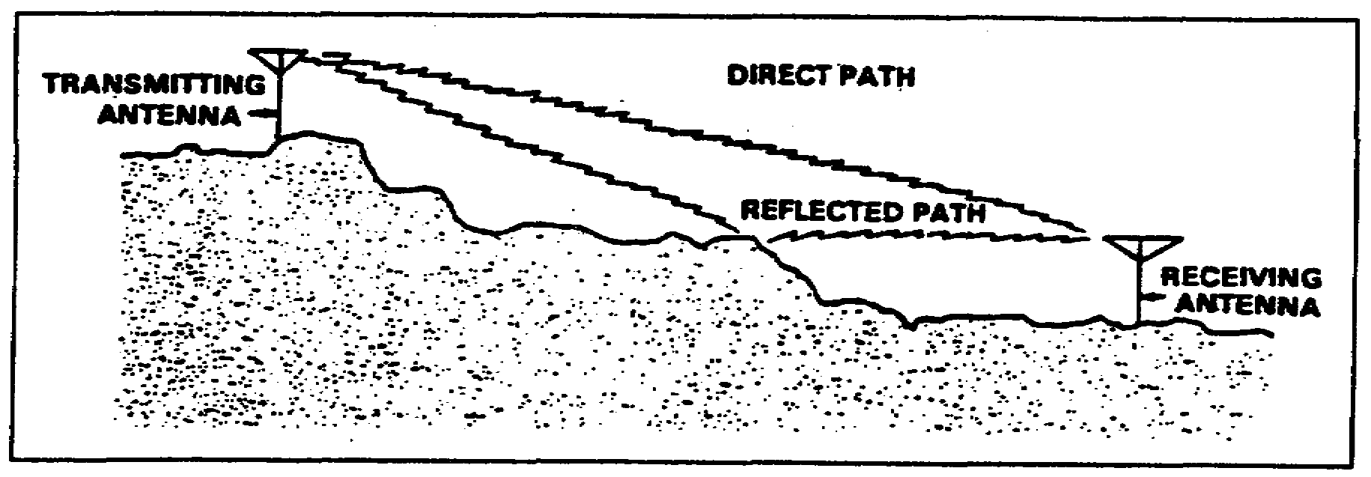
Figure 2-4. Space wave propagation.

(1) The primary path of the space wave is directly from the transmitting antenna to the receiving antenna. Consequently, the receiving antenna must be located within the radio horizon of the transmitting antenna. Because space waves are refracted slightly, even when propagated through the troposphere, the radio horizon is actually about one-third farther than the line-of-sight (natural) horizon.

(2) Although space waves suffer little ground attenuation, they nevertheless are susceptible to fading. Because space waves actually follow two paths of different length (direct path and ground-reflected path) to the receiving site, they may arrive in or out of phase. If these two component waves are received in phase, the result is a reinforced or stronger signal. Conversely, if they are received out of phase, they tend to cancel one another, resulting in a weak or fading signal.

4. Engineering considerations for ground wave systems. There are a number of factors that affect ground wave propagation. Some of these are:

a. Frequency. Using lower frequencies results in less ground loss and increases range.

b. Antenna characteristics. Using vertical polarization, when possible, reduces the effect of the Earth "shorting out" the electric field of the wave.

c. Power. Increasing the power output result in greater distance.

d. Time of day. Sources of noise (natural and manmade) affect radio wave propagation at different times of the day.

e. Terrain. The best propagation is achieved over conductive terrain. Conductive terrain absorbs less wave energy.

SS0130 2-6

5. Summary. In this lesson, you learned about ground wave propagation and the influences the Earth has on radio signals.

a. Ground waves are comprised of surface waves and space waves.

(1) Surface waves travel along the surface of the ground following the curvature of the Earth. Ground waves should be vertically polarized to reduce the attenuation caused by an induced voltage in the Earth.

(2) Space waves follow two paths-direct wave and ground-reflected. Space waves are slightly refracted in the Earth's atmosphere, but suffer little ground attenuation. The direct waves and ground-reflected waves can either reinforce or cancel each other, depending on whether or not they are received in phase or out of phase.

b. A ground wave that is vertically polarized has is electric field perpendicular to the Earth's surface. As a result, there is less wave energy loss than a horizontally polarized wave, the electric field of which is parallel to the Earth's surface and, therefore, subject to absorption.

c. Ground waves suffer ground loss; their strength is attenuated as the Earth absorbs energy. This causes the wave to tilt, the degree of which depends upon the conductivity of the surface. Poor conducting surfaces cause high loss of energy and greater tilt. Higher frequencies also contribute to increased tilt.

d. Ground wave propagation is affected by a number of factors, including frequency, antenna characteristics, power, time of day, and terrain.

2-7 SS0130

LESSON 2

PRACTICE EXERCISE

The following items will test your grasp of the material covered in this lesson. There is only one correct answer for each item. When you complete the exercise, check your answers with the answer key that follows. If you answer any item incorrectly, study again that part of the lesson which contains the portion involved.

1. Rocky terrain provides better conductivity for radio wave propagation than what other type of terrain?

A. Flat, loamy soil
B. Jungle terrain
C. Desert terrain
D. A large body of fresh water

2. Which region of the Earth's atmosphere is used for long-distance communications?

A. Troposphere
B. Exosphere
C. Ionosphere
D. Stratosphere

3. A radio receiver picks up a signal propagated over a ground wave. The signal strength depends on the frequency of the transmitter, the local weather conditions, and the Earth's shape and conductivity along the path. What else does the signal strength depend on?

A. The type of power being used
B. The operator's skills
C. The age of the receiving radio
D. The power output

4. A surface wave follows the curvature of the Earth due to which process?

A. Reflection
B. Refraction
C. Diffraction
D. Absorption

SS0130 2-8

5. What is the best type of surface (relative conductivity) for a ground wave to travel across?

A. Desert
B. Seawater
C. Rocky terrain
D. Jungle

6. What type of surface has tie least conductivity?

A. Jungle
B. Rocky terrain
C. Desert
D. Flat, loamy soil

7. As frequency increases, the angle of tilt of a wave front_________.

A. Increases
B. Decreases
C. Remains the same
D. Is nullified by poor conducting surfaces

8. Jungle terrain does what to a radio wave?

A. Reflects
B. Refracts
C. Diffracts
D. Absorbs

9. Which of the following is the true statement?

A. To reduce attenuation for surface waves, the amount of induced voltage must be increased
B. Vertical polarization is vastly superior to horizontal polarization for surface wave propagation
C. Horizontal polarization is vastly superior to vertical polarization for surface wave propagation
D. For surface wave propagation, there is no difference between horizontal and vertical polarization

2-9 SS0130

LESSON 2

PRACTICE EXERCISE

ANSWER KEY AND FEEDBACK

Item Correct Answer and Feedback

1. B. Jungle terrain

Rocky terrain provides better conductivity for radio wave propagation than jungle terrain. (page 2-5, Table 2-1)

2. C. Ionosphere

This region of the atmosphere is the most important because of its use for long-distance, point-to-point communications. (page 2-3, para 2c)

3. D. The power output

The strength of the ground wave at the receiver depends on the power output and frequency of the transmitter, the shape and conductivity of Earth along the transmission path, and the local weather conditions. (page 2-3, para 3)

4. C. Diffraction

A surface wave follows the curvature of the Earth due to the process of diffraction. (page 2-4, para 3a(1))

5. B. Sea water

Salt water has the best degree of conductivity. (page 2-4, para 3a(4))

6. A. Jungle

Jungle terrain is the worst environment. Radio waves are absorbed by jungle vegetation, reducing transmission range. (page 2-4, para 3a(4))

7. A. Increases

The angle of tilt increases as frequency increases. (page 2-5, para 3a(5)

SS0130 2-10

Item Correct Answer and Feedback

8. D. Absorbs

Radio waves are absorbed by jungle vegetation, reducing transmission range. (page 2-4, par 3a(4))

9. B. Vertical polarization is vastly superior to horizontal polarization for surface wave propagation. (page 2-4, para 3a(2)).

2-11 SS0130

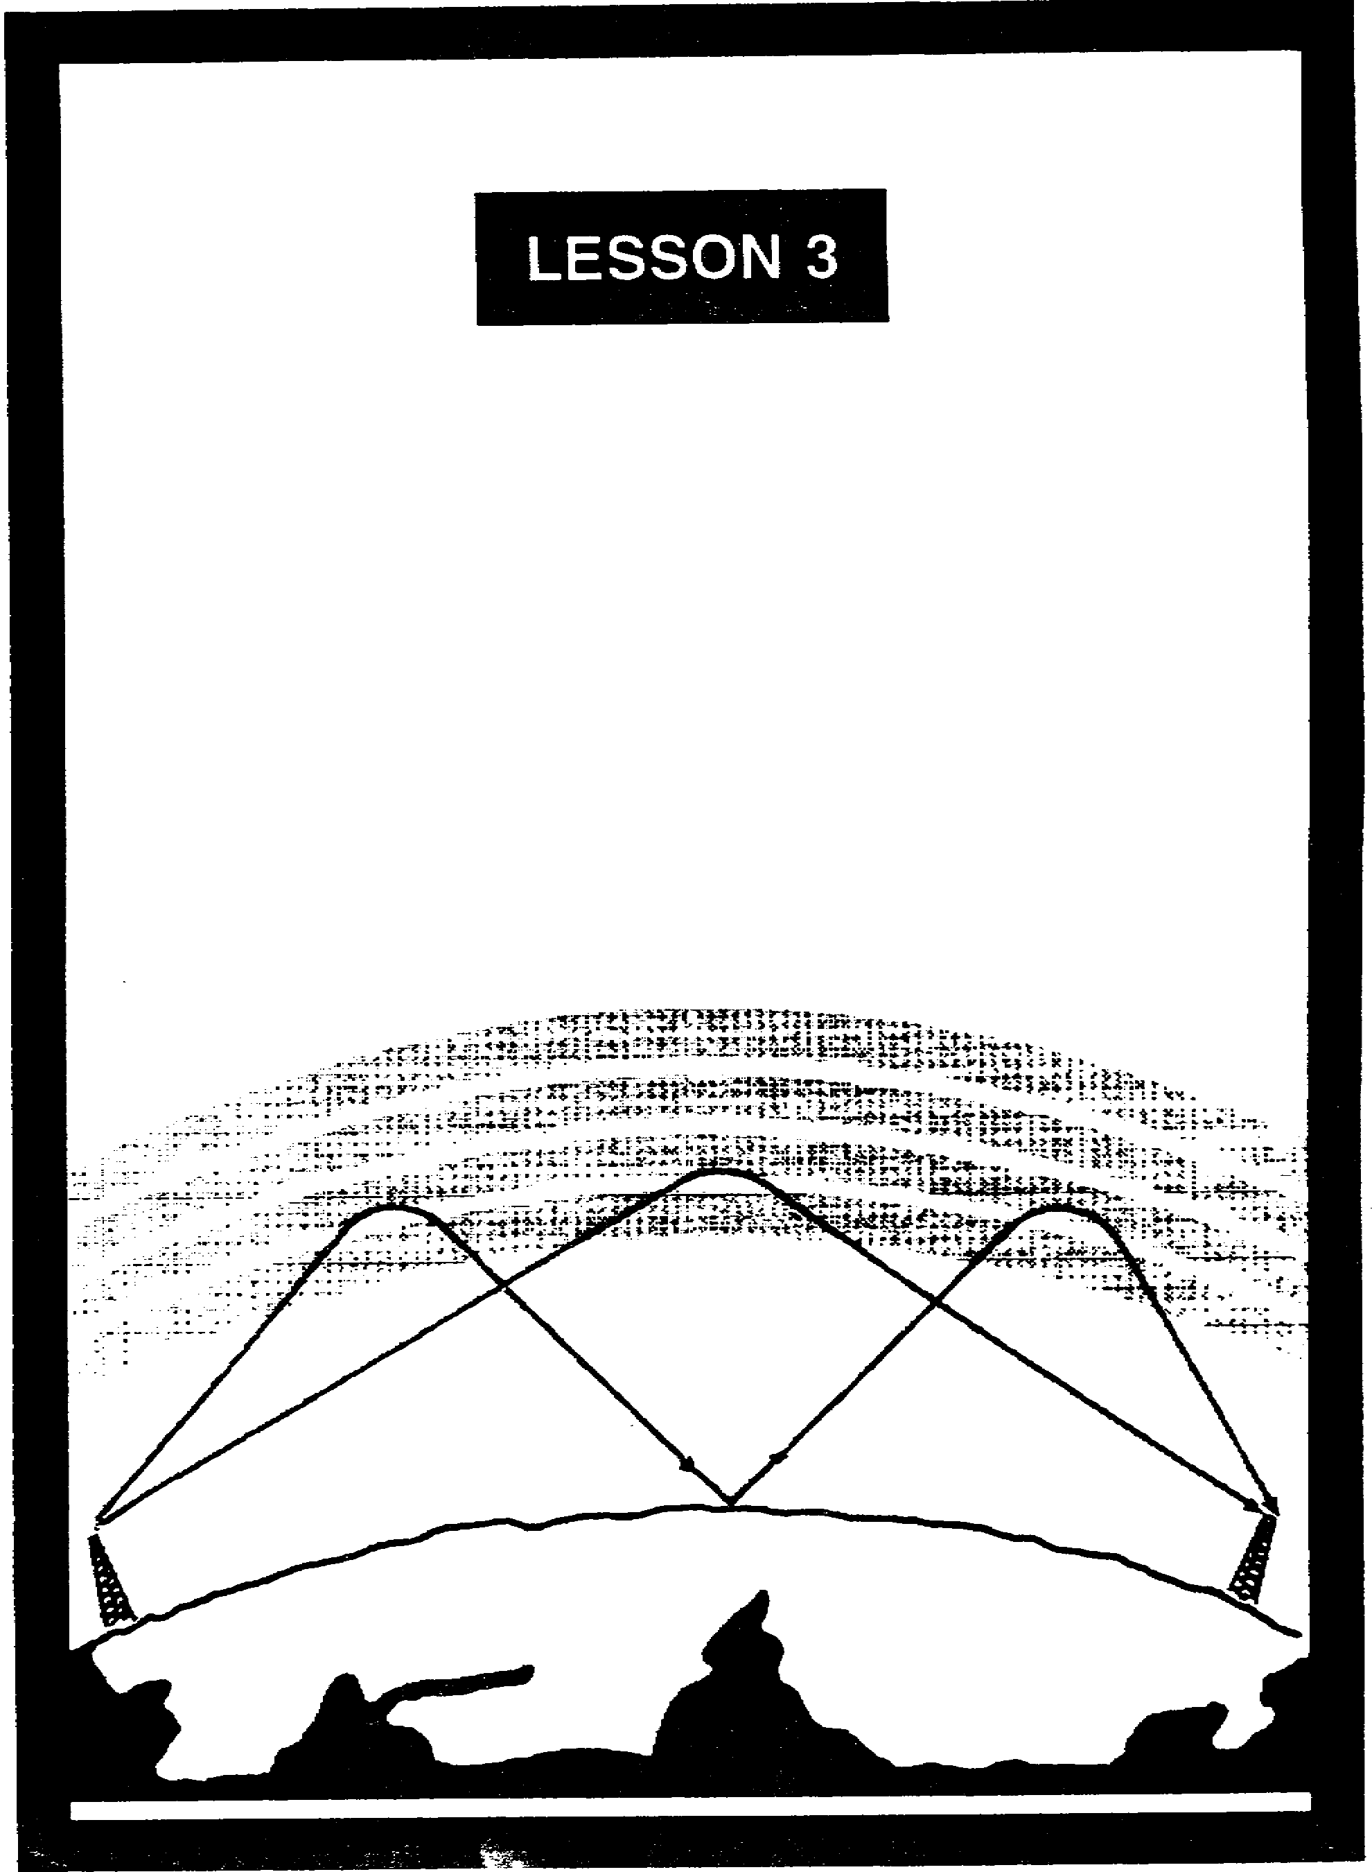

PRINCIPLES OF
SKY WAVE PROPAGATION

LESSON 3

PRINCIPALS OF SKY WAVE PROPAGATION

Critical Tasks: 01-5705.07-0003
01-5879.07-9001

OVERVIEW

LESSON DESCRIPTION:

In this lesson, you will learn about the fundamentals of sky wave propagation, specifically, the effects of atmospheric conditions on radio communications.

TERMINAL LEARNING OBJECTIVE:

ACTION: State the factors involved in sky wave propagation.

CONDITION: Given this lesson.

STANDARD: To demonstrate competence, you must achieve 70 percent on the subcourse examination.

REFERENCES: The material in this lesson was derived from FM 11-64 and FM 24-18.

INTRODUCTION

Sky wave propagation is used to communicate over long distances. Sky wave propagation allows transmitted signals to be reflected (bounced) off a portion of the Earth's ionosphere and picked up at a receiver hundreds, or even thousands of miles away. A common example of this phenomenon is heard on the AM broadcast band, when many distant stations can be heard after sunset or in the evening hours. Signal officers must understand this propagation mode because they may have to establish communications between a forward staging area in one country and an echelon of command in another. Usually, the HF band is used for sky wave propagation.

3-1 SS0130

1. Ionosphere. The ionosphere is the region (or layer) of the atmosphere that extends from 31 miles to about 250 miles above the Earth's surface. Its gets its name because it consists of several layers of electrically charged atoms called ions. Ions are formed by a process called ionization.

a. When high energy ultraviolet light waves from the sun enter the atmosphere's ionospheric region, they strike gas atoms, knocking negative electrons free. Normally, atoms are electrically neutral. When they lose an electron, atoms become positively charged and are called positive ions. This process of upsetting electrical neutrality is known as ionization. The rate at which ionization occurs depends on the density of atoms in the atmosphere and the intensity of the ultraviolet light waves, both of which vary with the activity of the sun. The ultraviolet waves striking the atmosphere are of different frequencies, causing several ionized layers to be formed at different altitudes. The density of ionized layers is partially attributed to the elevation angle of the sun, which changes constantly. Consequently, the altitude and thickness of the ionized layers vary, depending on the time of day and even the season of the year.

b. When free electrons and positive ions collide with each other, a reverse process called recombination occurs. This results in positive ions returning to their original neutral state. Recombination depends on the time of day. Between the hours of early morning and late afternoon, the rate of ionization exceeds the rate of recombination. It is during this period that the ionized layers reach their greatest density and exert maximum influence on radio waves. Conversely, during the late afternoon and early evening hours, the rate of recombination exceeds the rate of ionization, and the density of the ionized layers begins to decrease. This density decreases throughout the night, reaching a low point just before sunrise. You can better appreciate this phenomena by listening to a far away commercial AM radio station at night and at sunrise. As the ionization rate picks up, the reception grows fainter until you lose the station completely.

c. The ionosphere is composed of three regions (D, E, and F), as shown in Figure 3-1. The F region is further divided into two layers designated F1 (lower layer) and F2 (higher layer), which change with the position of the sun. The radiation in the ionosphere directly above a given point is greatest at noon, while it is least at night. When the radiation is not present, recombination sets in.

(1) The D region ranges to 55 miles above the Earth's surface. This low region of the atmosphere has low ionization. It refracts low frequency signals, but high frequencies pass through it, with some attenuation that varies with frequency and region density. The D region disappears after sunset because of recombination.

(2) The E region ranges from about 55 to 90 miles in altitude. After sunset, recombination occurs rapidly, and this region is almost gone by midnight. The E region is used during the day for HF radio transmissions ranging up to about 1500 miles.

SS0130 3-2

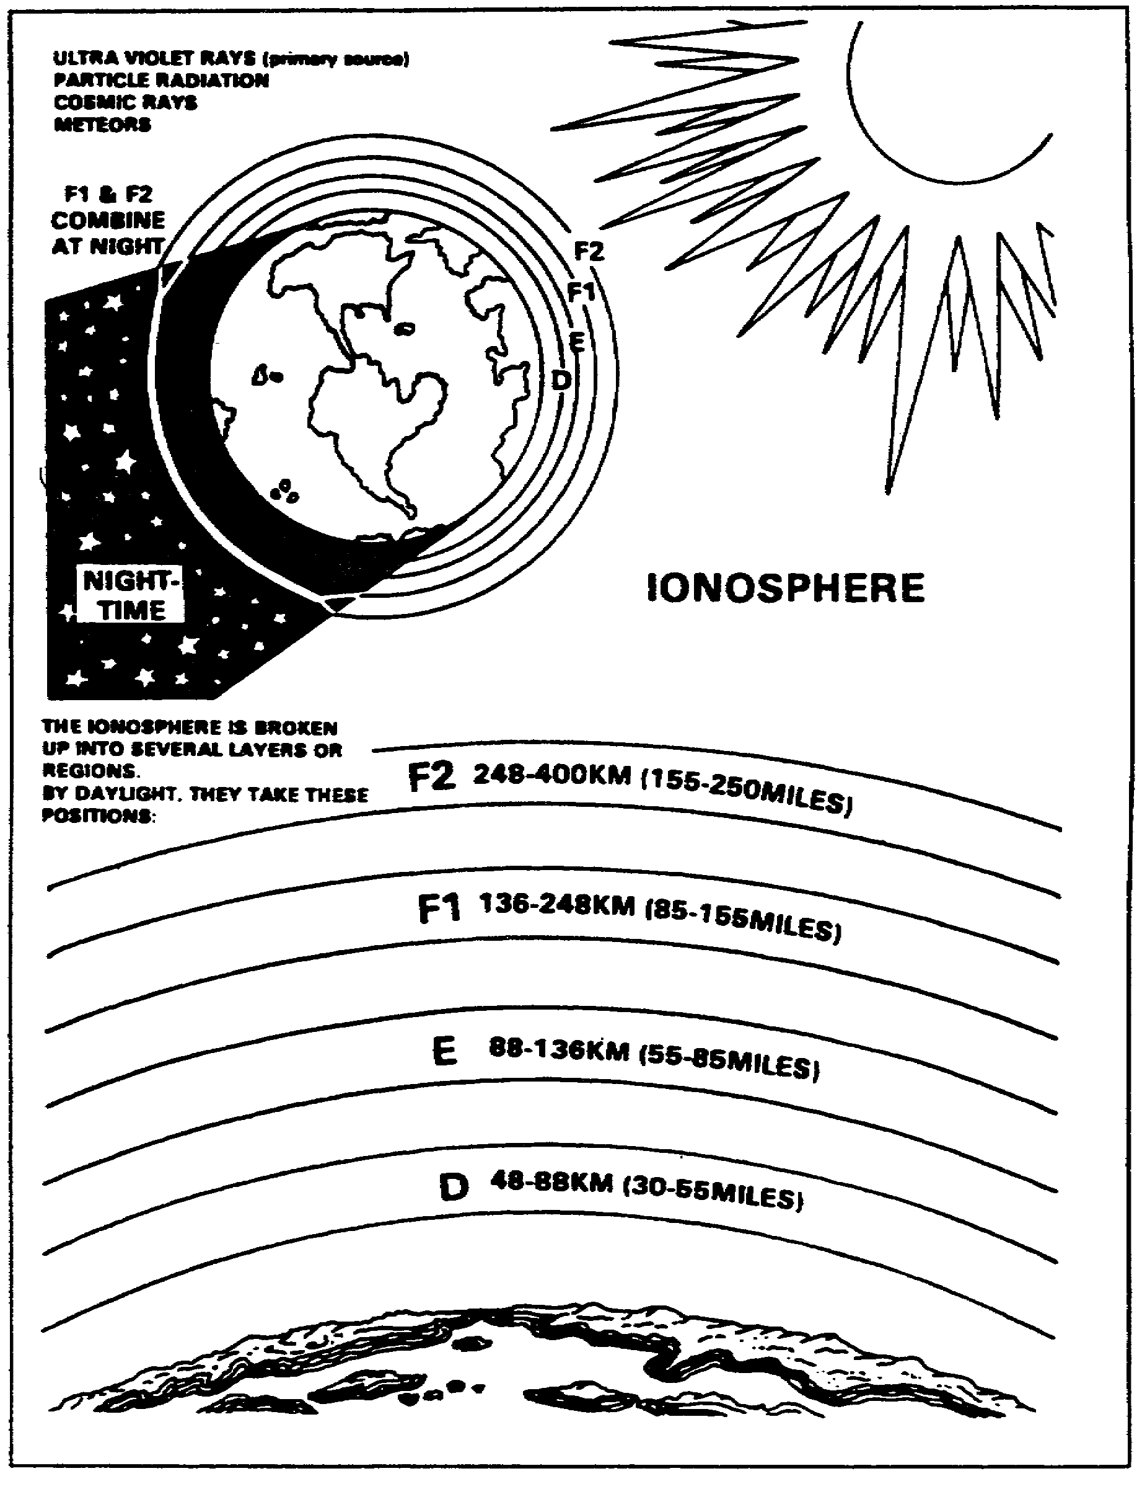
Figure 3-1. Layers of the ionosphere.

3-3 SS0130

(3) The F region ranges from about 90 to 240 miles high. During daylight hours, the F region separates into two layers-the F1 and F2 layers. At night these two layers combine. Recombination occurs slowly after sunset, so a fairly constant ionized layer is present at all times. The F layers are very useful for HF long-distance radio communications.

d. A radio wave transmitted into an ionized layer is refracted (bent) as it abruptly changes velocity while entering a new medium.

(1) The relationship between radio waves and ionization density is shown in Figure 3-2. Each layer has a central region of relatively dense ionization which tapers off in intensity both above and below the maximum region. As a radio wave strikes a region of increased ionization, its velocity increases, causing it to bend back toward the Earth. If a radio wave strikes a thin, very highly ionized layer, the wave may be bent back and appear to have been reflected, rather than refracted back to Earth. Ionospheric reflection is more likely to occur at
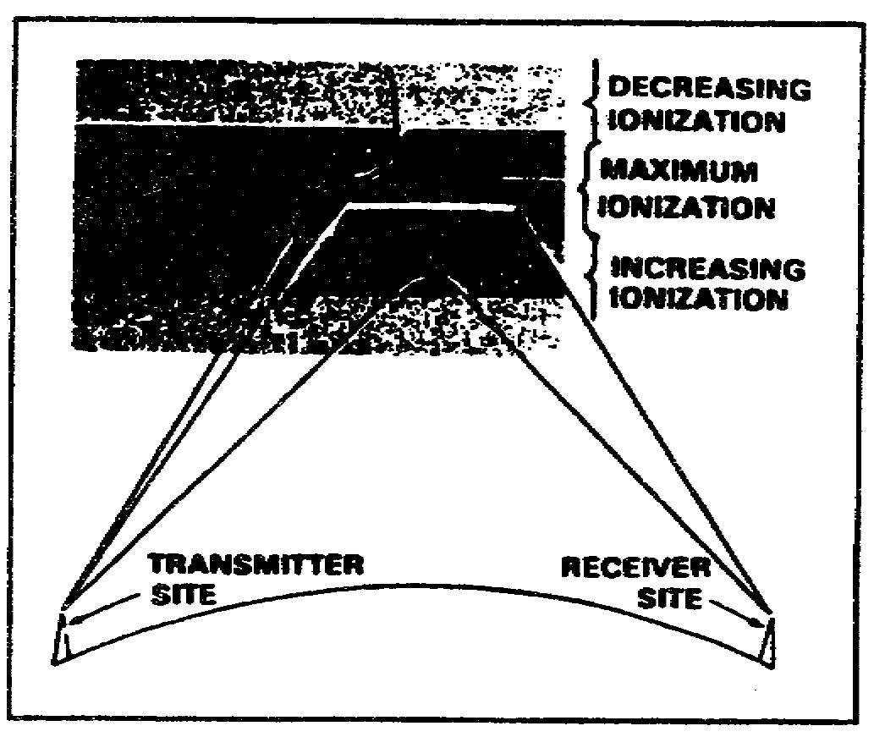
Figure 3-2. Effects of ionospheric density on radio waves.

long wavelengths (low frequencies). This is what occurs when you bounce an AM signal off the ionosphere and it is picked up many hundreds of miles away.

(2) For any given time, each ionospheric layer has a maximum frequency at which radio waves can be transmitted vertically and refracted back to Earth. This frequency is called the critical frequency. Radio waves transmitted at frequencies higher than the critical frequency of a given layer will pass through the layer and be lost in space. If this wave enters into an upper layer with a higher critical frequency, the wave will be refracted back to Earth. Radio waves of frequencies lower than the critical frequency will also be refracted back to Earth, unless they are absorbed or have been refracted from a lower layer. The lower the frequency of a radio wave, the more rapidly the wave is refracted by a given degree of ionization. Figure 3-3 shows three separate waves of different frequencies entering a ionospheric layer at the same angle. Notice that the 5-MHz wave is refracted quite sharply. The 20-MHz wave is refracted less sharply and returned to Earth at a greater distance. The 100-MHz wave is obviously greater than the critical frequency for that ionized layer. Therefore, it is not reacted but is lost in space.

SS0130 3-4

(3) The rate at which a wave of a given frequency is refracted by an ionized layer depends on the angle at which the wave enters the layer. Figure 3-4 shows three radio waves of the same frequency entering a layer at different angles. The angle at which wave A strikes the layer is too nearly vertical for the wave to be refracted to Earth. As the wave enters the layer, it is bent slightly but passes through the layer and is lost. When the wave is reduced to an angle that is less than vertical (wave B), it strikes the layer and is refracted back to Earth. The angle made by wave B is called the critical angle for that particular frequency. Any wave that leaves the antenna at an angle greater than the critical angle will penetrate the ionospheric layer for that frequency and will be lost in space. Wave C strikes the ionosphere at the smallest angle that can be refracted and still return to Earth. At any smaller angle, the wave will be refracted but will not return to Earth. As the radio wave's frequency is increased, the critical angle must be reduced for refraction to occur. This is illustrated in Figure 3-5, page 3-6. The 2-MHz wave strikes the layer at the critical angle for that frequency and is refracted back to Earth. Although the 5-MHz wave (broken line) strikes the ionosphere at a lesser angle, it nevertheless penetrates the layer and is lost. As the angle is lowered from the vertical, however, a critical angle for the 5-MHz wave is reached, and the wave is then refracted to Earth.

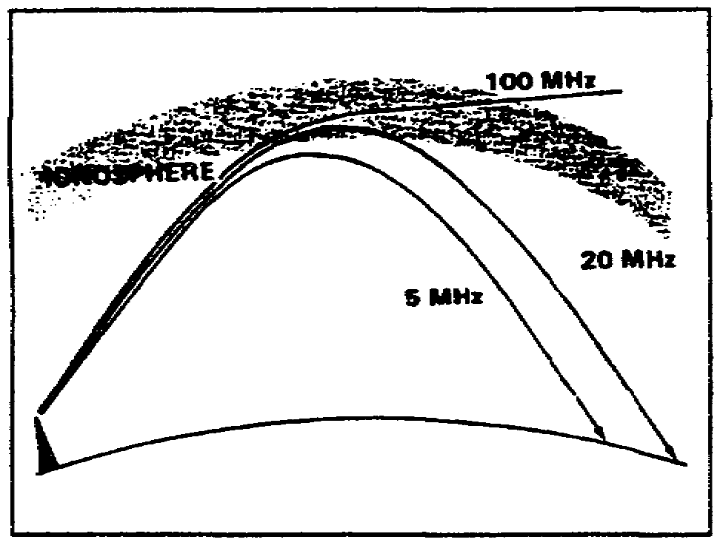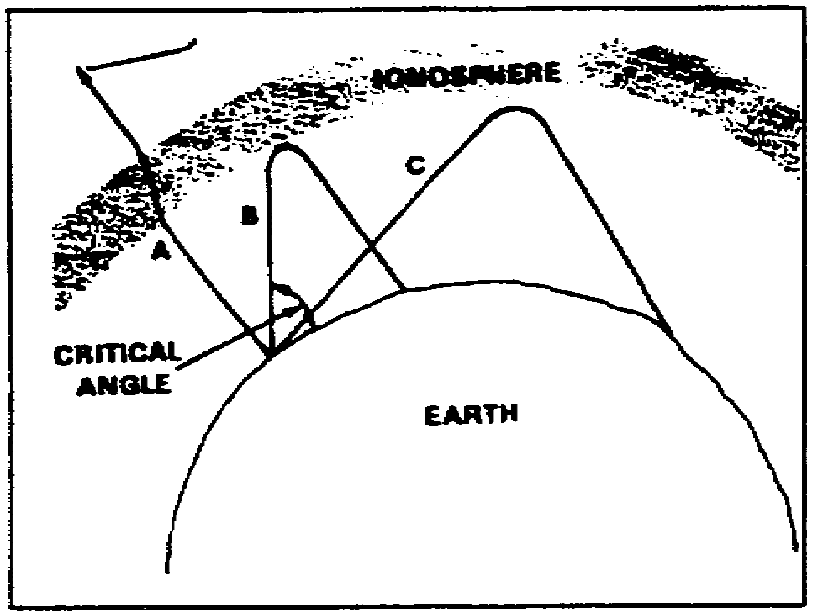
Figure 3-3. Frequency versus refraction Figure 3-4. Different incident angles of
and distance. radio waves.

e. The relationship between skip zone, skip distance, and ground wave coverage is shown in Figure 3-6, page 3-7.

(1) The skip distance is the distance from the transmitter to the point where the sky wave is first returned to Earth. The skip distance's size depends on the wave's frequency, the angle of incidence, and the degree of ionization present. Obviously, the skip distance will change through the day as the level of ionization changes.

3-5 SS0130

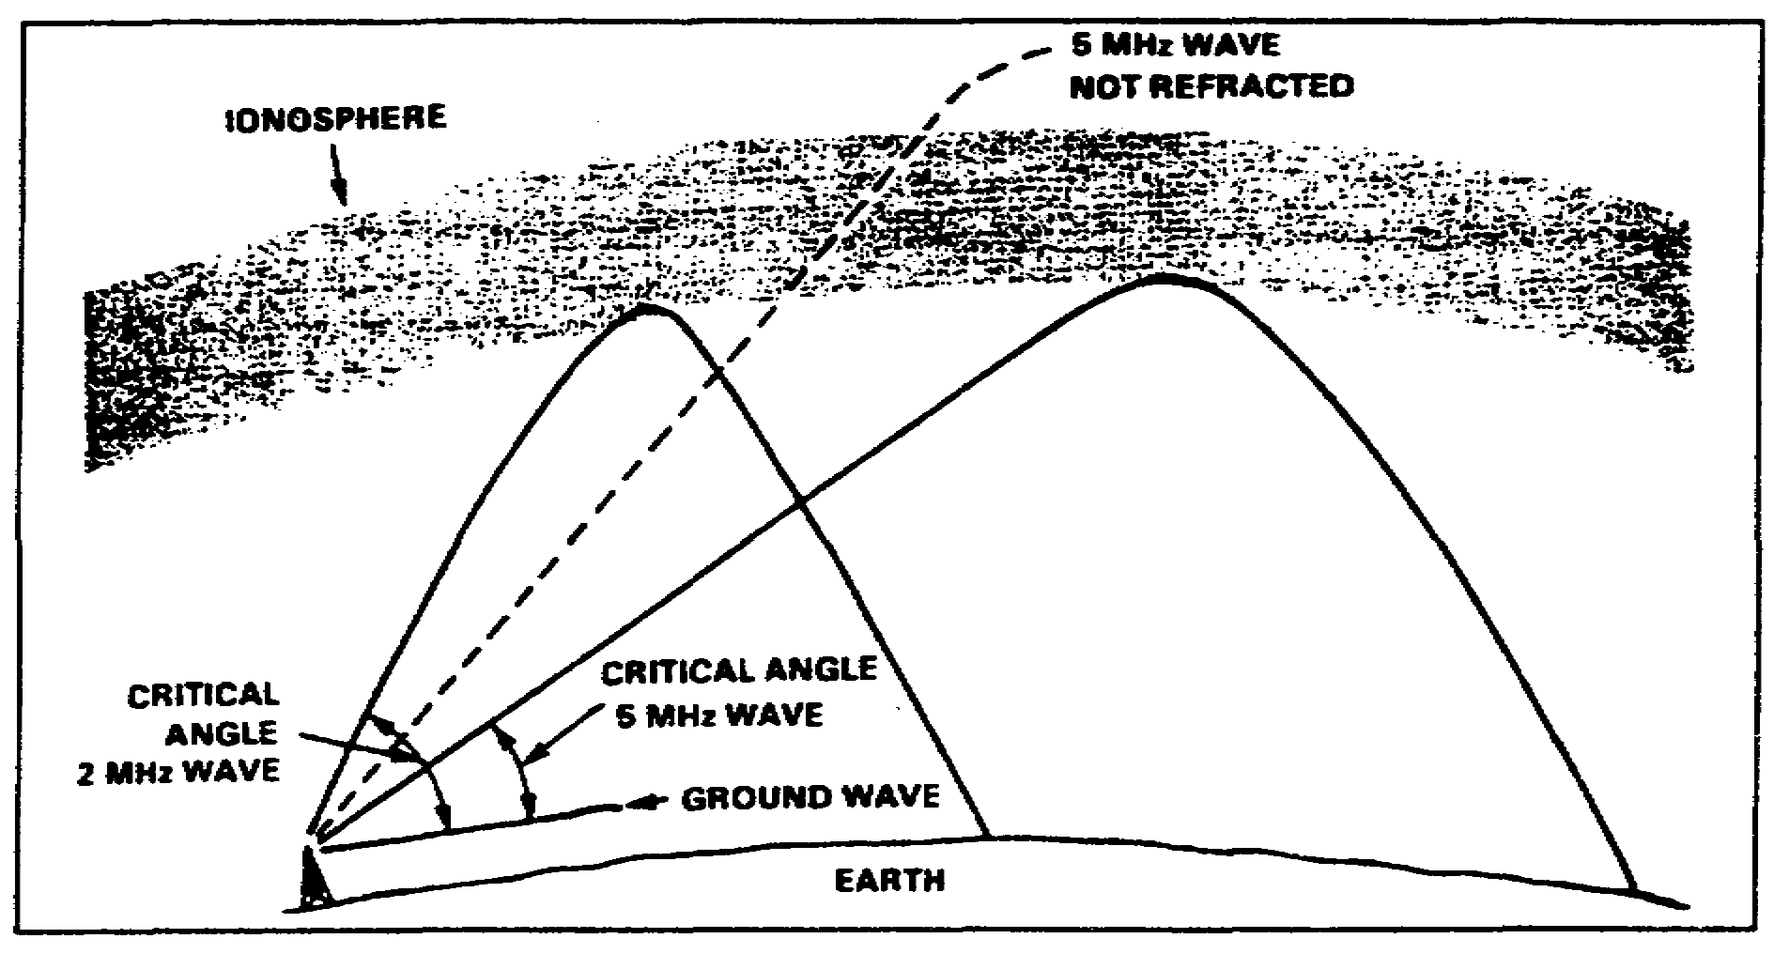
Figure 3-5. Effect of frequency on the critical angle.

(2) The skip zone is a zone of silence between the point where the ground wave becomes too weak for reception and the point where the sky wave is first returned to Earth. The skip zone's size depends on the extent of ground wave coverage and the skip distance. When the ground wave coverage is great enough or the skip distance is short enough that no zone of silence occurs, there is no skip zone. Occasionally, the first sky wave will return to Earth within range of the ground wave. If the sky and ground waves are nearly of equal intensity, the sky wave alternately reinforces and cancels the ground wave, causing severe fading. This is caused by the phase difference between the two waves, which is a result of the longer path traveled by the sky wave.

f. The relationship between frequency and angle of incidence can be seen in Figure 3-7. You can see how radio waves reach a receiver via several paths through one layer. The various angles are represented by dark lines and designated as rays 1 through 6. When the angle of incidence (ray 1) is relatively low with respect to the horizon, there is only slight penetration of the layer, and the propagation path is long. When the angle of incidence is increased (rays 2 and 3), the rays penetrate deeper into the layer, but the range decreases. Note that for rays 4 and 5, the angle is such that the RF energy penetrates into the central area of maximum ionization of the layer. These rays are refracted rather slowly and returned to the Earth at great distances. Finally, as the angle approaches vertical incidence (ray 6), the ray is not returned at all, but passes on through the layer into space.

SS0130 3-6

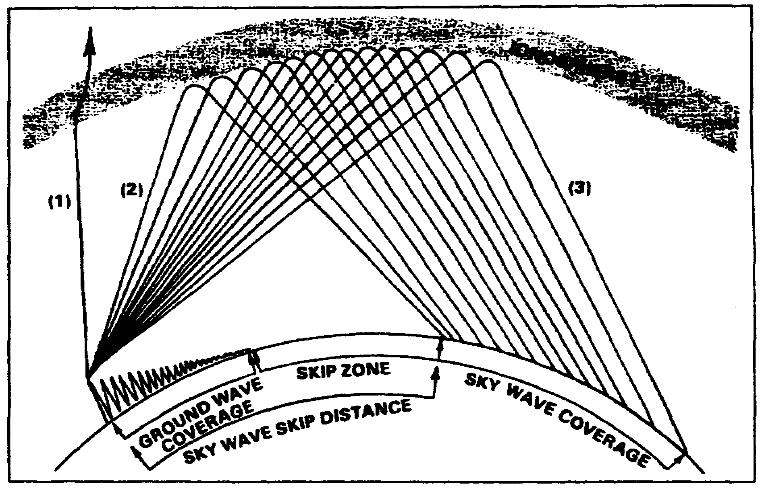
Figure 3-6. Relationship between skip zone, skip distance, and ground wave.

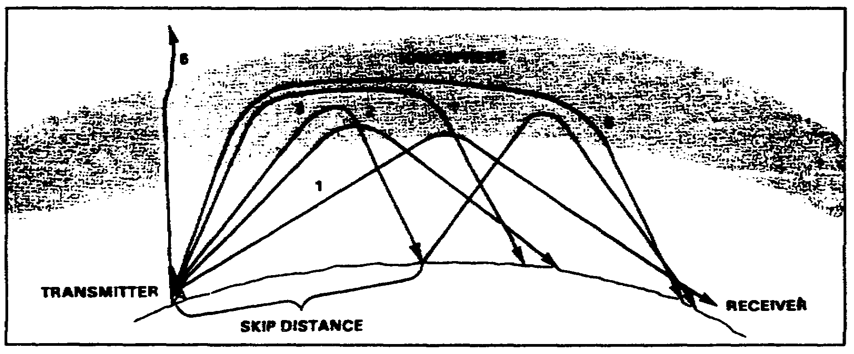
Figure 3-7. Ray paths for a fixed frequency with varying angles of incidence.

3-7 SS0130

2. Obstacles to propagation.

a. Absorption of RF energy in the ionosphere result in loss of signal strength and reduced transmission distances. Most ionospheric absorption occurs in the lower regions of the atmosphere where ionization density is greatest. As a radio wave passes into the ionosphere, it loses energy to the free electrons and ions. The highly dense D and E layers provide the greatest absorption of radio waves.

b. A radio signal will at times have variations in its strength. This is called fading. A radio wave refracted by the ionosphere or reflected from the Earth's surface may suffer changes in its polarization. This change in polarization results in weak signal reception. Fading is also caused by absorption of the RF energy in the ionosphere.

c. There are other losses which affect the ionospheric propagation of radio waves, besides energy losses in the atmosphere. These are ground-reflection loss and free space loss.

(1) Ground-reflection loss occurs when a transmitted signal is refracted off the ionosphere, strikes the Earth, and is reflected back to the ionosphere. RF energy is lost each time the radio wave is reflected from the surface. The amount of energy lost depends on the frequency of the wave, the angle of incidence, ground irregularities, and the electrical conductivity of the point of reflection.

(2) Free space loss occurs when a traveling radio wave spreads out, much like a flashlight's beam. Figure 3-8 shows the free space loss principle. As distance increases, the amount of energy contained in a wavefront will decrease. By the time the energy is received at the antenna, the wavefront is so spread out that the antenna extends into only a very small fraction of the wavefront.

d. Electromagnetic interference (EMI) can significantly reduce the quality of communications. This is because the radio receiver is picking up both the desired 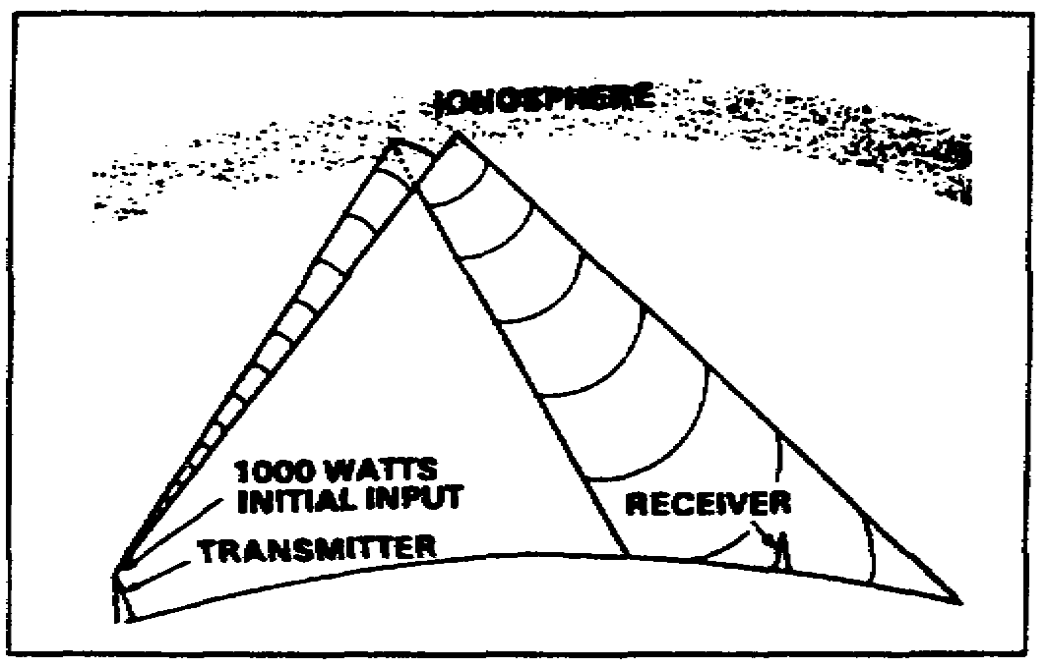
Figure 3-8. Free space loss principle.

transmission and electromagnetic radiation from an undesired source.

(1) Sources of EMI are manmade and natural. Examples of manmade EMI include assorted radio transmitters that can cause mutual interference, and various electrical devices that generate interfering signals, including ignition systems, generators, motors, and so forth. This is the reason you must never transmit a radio signal across a signal site, or position your communications systems near power lines. You can appreciate the severity of this type of interference the next time you listen to your car radio while driving under electrical power lines. The intensity of the radiation from the

SS0130 3-8

power lines overwhelms the signal (music) you have tuned in, resulting in a brief intolerable condition.

(2) Many sources of manmade interference may cause intense disruption of communications during the day and drop off at night when they are not in use. Natural interference is generated by phenomena such as thunderstorms, cosmic sources, and the sun. This causes static that you often hear when listening to a radio.

(3) Natural interference is disruptive, particularly in the HF band. Listening to your car radio on the AM band during a thunderstorm will reveal the impact of this interference; the intensity of the radiated energy from the lightning discharges interferes with the signal you have tuned in.

(4) At night, there are increases in the noise levels. This is attributed to both manmade and natural interferences. Because of the change at night in the layers of the F region, many spurious signals can be tuned in. Because of an increase in the number of signals reflected off of the ionosphere, more than one station may be heard simultaneously, causing interference. Some stations change their power output. This can also affect the noise levels.

e. Variations in the ionosphere are caused by the Earth's position relative to the sun, and by the sun's activity. The two types of variations are regular and irregular. Regular variations occur in cycles. They can be predicted with reasonable accuracy. Irregular variations occur as a result of abnormal solar activities. They are not predictable.

(1) Regular variations that affect the degree of ionization in the ionosphere are divided into four classes. These classes are daily, seasonal, 27-day sunspot cycle, and 11-year sunspot cycle.

(a) Daily variations are caused by the Earth's rotation.

(b) Seasonal variations are caused by the Earth revolving around the sun; the relative position of the sun moves from the upper hemisphere to the lower hemisphere with changes in seasons.

(c) The 27-day sunspot cycle is caused by the sun's rotation on its axis (one rotation each 27 days). As the sun rotates, sunspots are visible at 27-day intervals, causing variations in the ionization density of the layers. Sunspots are believed to be caused by violent eruptions on the sun and are characterized by unusually strong magnetic fields.

(d) The 11-year sunspot cycle is caused by the sunspot activity going from maximum through minimum and back to maximum levels of intensity every 11 years. During periods of maximum sunspot activity, the ionization density of all layers increases. Because of this, absorption in the D layer increases, and the critical frequencies for the E, F1, and F2 layers are higher. At these times, higher operating frequencies must be used for long-distance communications.

3-9 SS0130

(2) Irregular variations in the ionosphere can adversely affect communications without any advance warning. Common irregular variations include sporadic E, sudden ionospheric disturbances, and ionospheric storms.

(a) Sporadic E variations occur when the excessively ionized E layer often blanks out the reflections back from the higher layers. It may also cause unexpected propagation of signals hundreds of miles beyond the normal range.

(b) Sudden ionospheric disturbance (SID) is attributed to a bright solar eruption and results in abnormal ionization of the D layer. SID causes total absorption of all frequencies above about 1 MHz. It occurs without warning and can last from a few minutes to several hours. The immediate effect is that radio receivers seem to "go dead."

(c) Ionospheric storms are caused by disturbances in the Earth's magnetic field as a result of solar eruptions. During ionospheric storms, sky wave reception above about 1 MHz shows low intensity and is subject to a type of rapid blasting and fading called "flutter fading." These storms may last from several hours to days, and usually extend over the entire Earth.

3. Summary. In this lesson, you learned about sky wave propagation and the effects of atmospheric conditions on radio communications.

a. The ionosphere has three regions (D, E, and F). The F region is divided into two layers (F1 and F2). At night, these layers combine and are useful for HF long-distance radio communications.

b. Sky wave refraction and reflection vary according to the layer density in the ionosphere.

c. Each ionospheric layer has a maximum frequency (called the critical frequency) at which radio waves can be transmitted vertically and refracted back to Earth.

d. The rate at which a wave of a given frequency is reacted by an ionized layer depends on the angle at which the wave enters the layer.

e. Additional signal losses are due to ground-reflection loss and free space loss.

f. EMI is derived from two sources--manmade and natural. Examples of manmade EMI include assorted radio transmitters that can cause mutual interference, and various electrical devices that generate interfering signals. Natural EMI sources include thunderstorms, cosmic sources, and the sun.

g. Variations in the ionosphere are caused by the Earth's position in relation to the sun, and by the sun's activity.

(1) Regular variations that affect the degree of ionization in the ionosphere are divided into four classes. These classes are daily, seasonal, 27-day sunspot cycle, and 11-year sunspot cycle.

SS0130 3-10

(2) Irregular variations in the ionosphere can adversely affect communications without any advance warning Common irregular variations include sporadic E, sudden ionospheric disturbances, and ionospheric storms.

3-11 SS0130

LESSON 3

PRACTICE EXERCISE

The following items will test your grasp of the material covered in this lesson. There is only one correct answer for each item. When you complete the exercise, check your answers with the answer key that follows. If you answer any item incorrectly, study again that part of the lesson which contains the portion involved.

1. Which of the following are primarily used to make long-distance radio transmissions?

A. Reflected ground waves
B. Direct waves
C. Sky waves
D. Ground waves.

2. The rate at which ionization occurs in the ionosphere depends on the density of atoms in the atmosphere. What else does it depend on?

A. The intensity of the infrared light waves
B. The intensity of the ultraviolet light waves
C. The intensity of the visible light waves
D. The intensity of sound wave refraction

3. Which ionospheric layer has the least effect on bending the paths of high frequency radio waves?

A. D
B. E
C. F1
D. F2

4. Ionospheric reflection generally occurs using which frequencies?

A. EHF
B. VHF
C. UHF
D. LF

SS0130 3-12

5. The E layer of the ionosphere is useful for providing communications in ranges up to about how many miles?

A. 150
B. 1,500
C. 5,000
D. 7,500

6. The frequency of the wave, the angle of incidence, and what else determine the size of the skip distance?

A. The type of modulation
B. The height of the antenna
C. The degree of ionization present
D. The condition of the D layer

7. Which layer of the ionosphere attenuates high frequencies that pass through it?

A. D
B. E
C. F1
D. F2

8. SID may totally blank out long-distance propagation of all frequencies above how many MHz?

A. 1 MHz
B. 10 MHz
C. 50 MHz
D. 150 MHz

9. What is the maximum frequency at which radio waves can be transmitted vertically and refracted back to Earth?

A. The refracted frequency
B. The critical frequency
C. The reflected frequency
D. The diffracted frequency

3-13 SS0130

LESSON 3

PRACTICE EXERCISE

ANSWER KEY AND FEEDBACK

Item Correct Answer and Feedback

1. C. Sky waves

Sky wave propagation allows transmitted signals to be reflected (bounced) off a portion of the Earth's ionosphere and picked up at a receiver hundreds or even thousands of miles away. (page 3-1, Introduction)

2. B. The intensity of the ultraviolet light waves

The rat at which ionization occurs in the ionosphere depends on the density of atoms in the atmosphere and the intensity of the ultraviolet light waves. (page 3-2, para la)

3. A. D

The D layer refracts low frequency signals, but high frequencies pass right through it and are attenuated. (page 3-2, para c(l))

4. D. LF

Ionospheric reflection is more likely to occur at long wavelengths (low frequencies). (page 3-4, para 1d(1))

5. B. 1,500

The E region is used during the day for HF radio transmissions in ranges up to about 1500 miles. (page 3-2, para 1c(2))

6. C. Degree of ionization present

The size of the skip distance depends on the frequency of the wave, the angle of incidence, and the degree of ionization present. (page 3-5, para 1e(1))

7. A. D

The D layer refracts low frequency signals, but high frequencies pass right through it and are attenuated. (page 3-2, para 1c(l))

SS0130 3-14

Item Correct Answer and Feedback

8. A. 1 MHz

SID causes total absorption of all frequencies above about 1 MHz. (page 3-10, para 2e(2)(b))

9. B. The critical frequency

For any given time, each ionospheric layer has a maximum frequency at which radio waves can be transmitted vertically and refracted back to Earth. This frequency is called the critical frequency. (page 3-4, para 1d(2))

3-15 SS0130

